options(warn=-1)  
#load the csv file and provide the name as lv  
setwd('/Users/dsing001/myr/R_generic_code/myrpreprocess/R')  
library(ggplot2)  
library(discretization)  
library(randomForest)

## randomForest 4.6-10  
## Type rfNews() to see new features/changes/bug fixes.

library(ROCR)

## Loading required package: gplots  
## KernSmooth 2.23 loaded  
## Copyright M. P. Wand 1997-2009  
##   
## Attaching package: 'gplots'  
##   
## The following object is masked from 'package:stats':  
##   
## lowess

library(myrpreprocess)  
library(unbalanced)

## Loading required package: FNN  
## Loading required package: RANN

filename <- 'LendingClub.csv'  
header <- TRUE  
filename

## [1] "LendingClub.csv"

clscol='Class'  
  
#run prelim processing  
X <- read.csv(file=filename,header=header)  
clscolpos <- match(clscol,colnames(X))  
X <- X[complete.cases(X),]  
X <- moveclasscolintheend(X,clscolpos)  
X[,clscolpos] <- as.character(X[,clscolpos])  
  
X[X[,clscolpos]=='Creditworthy',clscolpos] <- '0'  
X[X[,clscolpos]=='Uncreditworthy',clscolpos] <- '1'  
X[,clscolpos] <- as.factor(as.numeric(X[,clscol]))  
  
  
  
#Now fix all the issues you want to with your data which you might have got idea from Pass_1 as well as from your own analytics.  
  
#Now convert all the factor columns to ordered in final model these wont be ordered  
factcols <- findallfactorcols(X[,-ncol(X)])  
print(factcols)

## [1] 2 4 6 7 9 15 20

for (cl in factcols){  
 ab <- as.data.frame(table(X[,cl]))  
 ab <- ab[order(ab[,2]),]  
 nwlvls <- paste(ab[,1],sep=',')  
 nwlvls <- as.data.frame(nwlvls)  
 nwlvls <- rownames(nwlvls)  
 ab <- cbind(ab,nwlvls)  
 print (ab)  
 X[,cl] <- as.character(X[,cl])  
 cl_vc <- X[,cl]  
 X[,cl] <- as.numeric(unlist(lapply(cl_vc,function(vl) ab[ab[,1]==vl,3])))  
 X[,cl] <- factor(X[,cl], levels = nwlvls)  
}

## Var1 Freq nwlvls  
## 2 60 Months 4184 1  
## 1 36 Months 20540 2  
## Var1 Freq nwlvls  
## 2 NOne 4 1  
## 3 OTHER 96 2  
## 4 OWN 2014 3  
## 1 MORTGAGE 10715 4  
## 5 RENT 11895 5  
## Var1 Freq nwlvls  
## 1 0 0 1  
## 12 Renewable Energy 53 2  
## 14 Vacation 207 3  
## 7 House 276 4  
## 5 Educationalal 299 5  
## 10 Moving 316 6  
## 9 Medical 414 7  
## 15 Wedding 575 8  
## 2 Car 837 9  
## 13 Small Business 1171 10  
## 8 Major Purchase 1321 11  
## 6 Home Improvement 1718 12  
## 11 Other 2594 13  
## 3 Credit Card 3231 14  
## 4 Debt Consolidation 11712 15  
## Var1 Freq nwlvls  
## 1 0 1  
## 23 ME 3 2  
## 14 IA 4 3  
## 30 NE 5 4  
## 15 ID 6 5  
## 17 IN 11 6  
## 43 TN 18 7  
## 27 MS 19 8  
## 47 VT 36 9  
## 42 SD 37 10  
## 28 MT 53 11  
## 51 WY 55 12  
## 2 AK 57 13  
## 10 DE 71 14  
## 50 WV 96 15  
## 13 HI 108 16  
## 31 NH 111 17  
## 33 NM 117 18  
## 40 RI 131 19  
## 9 DC 136 20  
## 4 AR 149 21  
## 18 KS 162 22  
## 19 KY 185 23  
## 45 UT 187 24  
## 37 OK 205 25  
## 20 LA 252 26  
## 38 OR 283 27  
## 3 AL 284 28  
## 49 WI 286 29  
## 41 SC 290 30  
## 34 NV 305 31  
## 26 MO 408 32  
## 25 MN 418 33  
## 8 CT 468 34  
## 29 NC 478 35  
## 24 MI 481 36  
## 7 CO 512 37  
## 48 WA 531 38  
## 5 AZ 596 39  
## 22 MD 657 40  
## 36 OH 713 41  
## 21 MA 808 42  
## 16 IL 867 43  
## 12 GA 874 44  
## 39 PA 887 45  
## 46 VA 907 46  
## 32 NJ 1100 47  
## 44 TX 1739 48  
## 11 FL 1740 49  
## 35 NY 2400 50  
## 6 CA 4478 51  
## Var1 Freq nwlvls  
## 4 Nine 1 1  
## 1 Eight 2 2  
## 7 Seven 2 3  
## 8 Six 8 4  
## 2 Five 16 5  
## 3 Four 27 6  
## 9 Three 148 7  
## 10 Two 469 8  
## 6 One 2118 9  
## 5 None 21933 10  
## Var1 Freq nwlvls  
## 1 Four 2 1  
## 4 Three 4 2  
## 5 Two 33 3  
## 3 One 1250 4  
## 2 None 23435 5  
## Var1 Freq nwlvls  
## 3 Two 5 1  
## 2 One 1002 2  
## 1 None 23717 3

# Now convert these columns to factor columns and in fact ordered factor columns  
numcols_to_be_converted <- c(3,8,11,12,13,14,17,18)  
X1 <- convert_num_field_to_ordered_fact_cols(X,numcols_to_be_converted,alpha=0.01)  
X[,numcols_to_be_converted] <- X1  
# see whether new cols are converted to fact columns.  
str(X)

## 'data.frame': 24724 obs. of 21 variables:  
## $ Loan.Amount : int 25000 7000 1200 10800 7500 3000 4000 5600 3200 4000 ...  
## $ Loan.Term : Factor w/ 2 levels "1","2": 2 2 2 2 2 2 2 2 2 2 ...  
## $ Employment.Length : Ord.factor w/ 3 levels "1"<"2"<"3": 1 1 3 2 2 2 1 2 2 1 ...  
## $ Home.Ownership : Factor w/ 5 levels "1","2","3","4",..: 5 5 3 5 5 4 4 5 5 4 ...  
## $ Annual.Income : num 85000 65000 54000 32000 85000 80800 148000 45000 54000 60000 ...  
## $ Loan.Purpose : Factor w/ 15 levels "1","2","3","4",..: 7 6 7 7 7 6 6 7 7 15 ...  
## $ Address.State : Factor w/ 51 levels "1","2","3","4",..: 47 46 43 28 47 43 43 35 37 30 ...  
## $ Debt.To.Income.Ratio : Ord.factor w/ 3 levels "1"<"2"<"3": 3 2 1 2 1 2 3 1 1 1 ...  
## $ No..Delinquencies.In.Last.2.Years: Factor w/ 10 levels "1","2","3","4",..: 2 2 2 2 2 10 2 2 2 2 ...  
## $ Earliest.Credit.Line.Opened : num 34380 36821 31068 35411 36846 ...  
## $ FICO.Credit.Score : Ord.factor w/ 6 levels "1"<"2"<"3"<"4"<..: 3 2 2 2 3 1 3 1 4 3 ...  
## $ No..Inquiries.In.Last.6.Months : Ord.factor w/ 3 levels "1"<"2"<"3": 1 1 1 2 2 1 1 1 1 1 ...  
## $ Months.Since.Last.Delinquency : Ord.factor w/ 4 levels "1"<"2"<"3"<"4": 1 1 4 4 1 2 1 4 1 1 ...  
## $ No..Of.Credit.Lines : Ord.factor w/ 3 levels "1"<"2"<"3": 3 3 3 3 2 3 3 3 3 3 ...  
## $ No..Adverse.Public.Records : Factor w/ 5 levels "1","2","3","4",..: 5 5 5 5 5 5 5 4 5 5 ...  
## $ Total.Credit.Balance : int 28854 33623 2584 3511 33667 4740 50000 3839 3198 24220 ...  
## $ Use.Of.Credit.Line : Ord.factor w/ 8 levels "1"<"2"<"3"<"4"<..: 4 7 4 3 7 4 4 7 4 6 ...  
## $ Total.Number.Of.Credit.Lines : Ord.factor w/ 5 levels "1"<"2"<"3"<"4"<..: 5 1 3 5 2 3 3 2 2 4 ...  
## $ Loan.Application.Description : int 308 71 748 403 293 487 363 340 141 824 ...  
## $ No..Of.Public.Record.Bankruptcies: Factor w/ 3 levels "1","2","3": 3 3 3 3 3 3 3 3 3 3 ...  
## $ Class : Factor w/ 2 levels "0","1": 1 1 1 1 1 1 1 2 1 2 ...

# Now break the data into 3 parts, train data, test data and valid data as feature selection should always be done on train data and never on test and valid data.  
#valid ratio 0.3 means it will be 30 % of data remaning after test_ratio has been splitted. so if test_ratio is 0.3 and valid_ratio is 0.3 valid data will be (1-0.3)*0.3 i.e. 0.21 of total data passed  
dt_set <- generte_train_test_validset(X,test_ratio=0.3,valid_ratio=0.3)

## [1] "we have valid test"  
## [1] "valid set is generated"

train_data <- dt_set$train_data  
test_data <- dt_set$test_data  
valid_data <- dt_set$valid_data  
  
#write the train_data,test_data and valid_data now to file. Use this in 3rd step of modelling.  
#however, you can split them again but make sure that the feature selection part is run once or if you want to repeat it on same data  
#to be honest :) .  
  
  
# Now remove the test and valid data  
  
  
  
train_data <- dt_set$train_data  
td <- merge_unord_lvls(train_data,test_data,valid_data)

## [1] 0 0 0 0 0 0  
## Levels: 0 1  
## [1] 2 4 6 7 9 15 20 21  
## [1] "Home.Ownership"  
## [1] "1" "2" "3" "4" "5"  
## [1] 4  
## [1] 4  
## [1] "print the p values for factor levels which are independent.These are order by p values. It is for column Home.Ownership"  
## [1] "0.999999999999999"  
## [1] 9  
## [1] 3  
## [1] "Home.Ownership"  
## [1] "1" "2" "4" "5"  
## [1] 4  
## [1] 3  
## [1] "print the p values for factor levels which are independent.These are order by p values. It is for column Home.Ownership"  
## [1] "0.999999999999999"  
## [1] 6  
## [1] 4  
## [1] "Home.Ownership"  
## [1] "1" "2" "5"  
## [1] 4  
## [1] 2  
## [1] "print the p values for factor levels which are independent.These are order by p values. It is for column Home.Ownership"  
## [1] "0.980425721885057"  
## [1] 3  
## [1] 5  
## [1] "Loan.Purpose"  
## [1] "1" "2" "3" "4" "5" "6" "7" "8" "9" "10" "11" "12" "13" "14"  
## [15] "15"  
## [1] 6  
## [1] 14  
## [1] "print the p values for factor levels which are independent.These are order by p values. It is for column Loan.Purpose"  
## [1] "8.52221571082758e-08"  
## [1] 76  
## [1] 2  
## [1] "Loan.Purpose"  
## [1] "1" "3" "4" "5" "6" "7" "8" "9" "10" "11" "12" "13" "14" "15"  
## [1] 6  
## [1] 13  
## [1] "print the p values for factor levels which are independent.These are order by p values. It is for column Loan.Purpose"  
## [1] "8.52221571082758e-08"  
## [1] 76  
## [1] 10  
## [1] "Loan.Purpose"  
## [1] "1" "3" "4" "5" "6" "7" "8" "9" "11" "12" "13" "14" "15"  
## [1] 6  
## [1] 12  
## [1] "print the p values for factor levels which are independent.These are order by p values. It is for column Loan.Purpose"  
## [1] "8.52221571082758e-08"  
## [1] 62  
## [1] 12  
## [1] "Loan.Purpose"  
## [1] "1" "3" "4" "5" "6" "7" "8" "9" "11" "13" "14" "15"  
## [1] 6  
## [1] 11  
## [1] "print the p values for factor levels which are independent.These are order by p values. It is for column Loan.Purpose"  
## [1] "9.74956062945533e-14"  
## [1] 51  
## [1] 14  
## [1] "Loan.Purpose"  
## [1] "1" "3" "4" "5" "6" "7" "8" "9" "11" "13" "15"  
## [1] 6  
## [1] 10  
## [1] "print the p values for factor levels which are independent.These are order by p values. It is for column Loan.Purpose"  
## [1] "9.74956062945533e-14"  
## [1] 41  
## [1] 8  
## [1] "Loan.Purpose"  
## [1] "1" "3" "4" "5" "6" "7" "9" "11" "13" "15"  
## [1] 6  
## [1] 9  
## [1] "print the p values for factor levels which are independent.These are order by p values. It is for column Loan.Purpose"  
## [1] "9.99777634290201e-07"  
## [1] 32  
## [1] 9  
## [1] "Loan.Purpose"  
## [1] "1" "3" "4" "5" "6" "7" "11" "13" "15"  
## [1] 6  
## [1] 8  
## [1] "print the p values for factor levels which are independent.These are order by p values. It is for column Loan.Purpose"  
## [1] "9.99777634290201e-07"  
## [1] 24  
## [1] 13  
## [1] "Loan.Purpose"  
## [1] "1" "3" "4" "5" "6" "7" "11" "15"  
## [1] 6  
## [1] 7  
## [1] "print the p values for factor levels which are independent.These are order by p values. It is for column Loan.Purpose"  
## [1] "9.99777634290201e-07"  
## [1] 17  
## [1] 11  
## [1] "Loan.Purpose"  
## [1] "1" "3" "4" "5" "6" "7" "15"  
## [1] 6  
## [1] 6  
## [1] "print the p values for factor levels which are independent.These are order by p values. It is for column Loan.Purpose"  
## [1] "6.56806047446777e-25"  
## [1] 11  
## [1] 6  
## [1] "Loan.Purpose"  
## [1] "1" "3" "4" "5" "7" "15"  
## [1] 6  
## [1] 5  
## [1] "print the p values for factor levels which are independent.These are order by p values. It is for column Loan.Purpose"  
## [1] "9.57507354778416e-10"  
## [1] 6  
## [1] 15  
## [1] "Loan.Purpose"  
## [1] "1" "3" "4" "5" "7"  
## [1] 6  
## [1] 4  
## [1] "print the p values for factor levels which are independent.These are order by p values. It is for column Loan.Purpose"  
## [1] "6.85861235307797e-11"  
## [1] 4  
## [1] 7  
## [1] "Loan.Purpose"  
## [1] "1" "3" "4" "5"  
## [1] 6  
## [1] 3  
## [1] "print the p values for factor levels which are independent.These are order by p values. It is for column Loan.Purpose"  
## [1] "7.97006466492763e-12"  
## [1] 1  
## [1] 5  
## [1] "Loan.Purpose"  
## [1] "1" "3" "4"  
## [1] 6  
## [1] 2  
## [1] "print the p values for factor levels which are independent.These are order by p values. It is for column Loan.Purpose"  
## [1] "9.0101420428284e-26"  
## [1] 2  
## [1] 4  
## [1] "Address.State"  
## [1] "1" "2" "3" "4" "5" "6" "7" "8" "9" "10" "11" "12" "13" "14"  
## [15] "15" "16" "17" "18" "19" "20" "21" "22" "23" "24" "25" "26" "27" "28"  
## [29] "29" "30" "31" "32" "33" "34" "35" "36" "37" "38" "39" "40" "41" "42"  
## [43] "43" "44" "45" "46" "47" "48" "49" "50" "51"  
## [1] 7  
## [1] 50  
## [1] "print the p values for factor levels which are independent.These are order by p values. It is for column Address.State"  
## [1] "NaN"  
## [1] 1131  
## [1] 2  
## [1] "Address.State"  
## [1] "1" "3" "4" "5" "6" "7" "8" "9" "10" "11" "12" "13" "14" "15"  
## [15] "16" "17" "18" "19" "20" "21" "22" "23" "24" "25" "26" "27" "28" "29"  
## [29] "30" "31" "32" "33" "34" "35" "36" "37" "38" "39" "40" "41" "42" "43"  
## [43] "44" "45" "46" "47" "48" "49" "50" "51"  
## [1] 7  
## [1] 49  
## [1] "print the p values for factor levels which are independent.These are order by p values. It is for column Address.State"  
## [1] "NaN"  
## [1] 1131  
## [1] 3  
## [1] "Address.State"  
## [1] "1" "4" "5" "6" "7" "8" "9" "10" "11" "12" "13" "14" "15" "16"  
## [15] "17" "18" "19" "20" "21" "22" "23" "24" "25" "26" "27" "28" "29" "30"  
## [29] "31" "32" "33" "34" "35" "36" "37" "38" "39" "40" "41" "42" "43" "44"  
## [43] "45" "46" "47" "48" "49" "50" "51"  
## [1] 7  
## [1] 48  
## [1] "print the p values for factor levels which are independent.These are order by p values. It is for column Address.State"  
## [1] "NaN"  
## [1] 1099  
## [1] 9  
## [1] "Address.State"  
## [1] "1" "4" "5" "6" "7" "8" "10" "11" "12" "13" "14" "15" "16" "17"  
## [15] "18" "19" "20" "21" "22" "23" "24" "25" "26" "27" "28" "29" "30" "31"  
## [29] "32" "33" "34" "35" "36" "37" "38" "39" "40" "41" "42" "43" "44" "45"  
## [43] "46" "47" "48" "49" "50" "51"  
## [1] 7  
## [1] 47  
## [1] "print the p values for factor levels which are independent.These are order by p values. It is for column Address.State"  
## [1] "NaN"  
## [1] 1056  
## [1] 8  
## [1] "Address.State"  
## [1] "1" "4" "5" "6" "7" "10" "11" "12" "13" "14" "15" "16" "17" "18"  
## [15] "19" "20" "21" "22" "23" "24" "25" "26" "27" "28" "29" "30" "31" "32"  
## [29] "33" "34" "35" "36" "37" "38" "39" "40" "41" "42" "43" "44" "45" "46"  
## [43] "47" "48" "49" "50" "51"  
## [1] 7  
## [1] 46  
## [1] "print the p values for factor levels which are independent.These are order by p values. It is for column Address.State"  
## [1] "NaN"  
## [1] 1015  
## [1] 11  
## [1] "Address.State"  
## [1] "1" "4" "5" "6" "7" "10" "12" "13" "14" "15" "16" "17" "18" "19"  
## [15] "20" "21" "22" "23" "24" "25" "26" "27" "28" "29" "30" "31" "32" "33"  
## [29] "34" "35" "36" "37" "38" "39" "40" "41" "42" "43" "44" "45" "46" "47"  
## [43] "48" "49" "50" "51"  
## [1] 7  
## [1] 45  
## [1] "print the p values for factor levels which are independent.These are order by p values. It is for column Address.State"  
## [1] "NaN"  
## [1] 974  
## [1] 34  
## [1] "Address.State"  
## [1] "1" "4" "5" "6" "7" "10" "12" "13" "14" "15" "16" "17" "18" "19"  
## [15] "20" "21" "22" "23" "24" "25" "26" "27" "28" "29" "30" "31" "32" "33"  
## [29] "35" "36" "37" "38" "39" "40" "41" "42" "43" "44" "45" "46" "47" "48"  
## [43] "49" "50" "51"  
## [1] 7  
## [1] 44  
## [1] "print the p values for factor levels which are independent.These are order by p values. It is for column Address.State"  
## [1] "NaN"  
## [1] 941  
## [1] 6  
## [1] "Address.State"  
## [1] "1" "4" "5" "7" "10" "12" "13" "14" "15" "16" "17" "18" "19" "20"  
## [15] "21" "22" "23" "24" "25" "26" "27" "28" "29" "30" "31" "32" "33" "35"  
## [29] "36" "37" "38" "39" "40" "41" "42" "43" "44" "45" "46" "47" "48" "49"  
## [43] "50" "51"  
## [1] 7  
## [1] 43  
## [1] "print the p values for factor levels which are independent.These are order by p values. It is for column Address.State"  
## [1] "NaN"  
## [1] 908  
## [1] 49  
## [1] "Address.State"  
## [1] "1" "4" "5" "7" "10" "12" "13" "14" "15" "16" "17" "18" "19" "20"  
## [15] "21" "22" "23" "24" "25" "26" "27" "28" "29" "30" "31" "32" "33" "35"  
## [29] "36" "37" "38" "39" "40" "41" "42" "43" "44" "45" "46" "47" "48" "50"  
## [43] "51"  
## [1] 7  
## [1] 42  
## [1] "print the p values for factor levels which are independent.These are order by p values. It is for column Address.State"  
## [1] "NaN"  
## [1] 876  
## [1] 28  
## [1] "Address.State"  
## [1] "1" "4" "5" "7" "10" "12" "13" "14" "15" "16" "17" "18" "19" "20"  
## [15] "21" "22" "23" "24" "25" "26" "27" "29" "30" "31" "32" "33" "35" "36"  
## [29] "37" "38" "39" "40" "41" "42" "43" "44" "45" "46" "47" "48" "50" "51"  
## [1] 7  
## [1] 41  
## [1] "print the p values for factor levels which are independent.These are order by p values. It is for column Address.State"  
## [1] "NaN"  
## [1] 836  
## [1] 7  
## [1] "Address.State"  
## [1] "1" "4" "5" "10" "12" "13" "14" "15" "16" "17" "18" "19" "20" "21"  
## [15] "22" "23" "24" "25" "26" "27" "29" "30" "31" "32" "33" "35" "36" "37"  
## [29] "38" "39" "40" "41" "42" "43" "44" "45" "46" "47" "48" "50" "51"  
## [1] 7  
## [1] 40  
## [1] "print the p values for factor levels which are independent.These are order by p values. It is for column Address.State"  
## [1] "NaN"  
## [1] 796  
## [1] 41  
## [1] "Address.State"  
## [1] "1" "4" "5" "10" "12" "13" "14" "15" "16" "17" "18" "19" "20" "21"  
## [15] "22" "23" "24" "25" "26" "27" "29" "30" "31" "32" "33" "35" "36" "37"  
## [29] "38" "39" "40" "42" "43" "44" "45" "46" "47" "48" "50" "51"  
## [1] 7  
## [1] 39  
## [1] "print the p values for factor levels which are independent.These are order by p values. It is for column Address.State"  
## [1] "NaN"  
## [1] 759  
## [1] 14  
## [1] "Address.State"  
## [1] "1" "4" "5" "10" "12" "13" "15" "16" "17" "18" "19" "20" "21" "22"  
## [15] "23" "24" "25" "26" "27" "29" "30" "31" "32" "33" "35" "36" "37" "38"  
## [29] "39" "40" "42" "43" "44" "45" "46" "47" "48" "50" "51"  
## [1] 7  
## [1] 38  
## [1] "print the p values for factor levels which are independent.These are order by p values. It is for column Address.State"  
## [1] "NaN"  
## [1] 728  
## [1] 50  
## [1] "Address.State"  
## [1] "1" "4" "5" "10" "12" "13" "15" "16" "17" "18" "19" "20" "21" "22"  
## [15] "23" "24" "25" "26" "27" "29" "30" "31" "32" "33" "35" "36" "37" "38"  
## [29] "39" "40" "42" "43" "44" "45" "46" "47" "48" "51"  
## [1] 7  
## [1] 37  
## [1] "print the p values for factor levels which are independent.These are order by p values. It is for column Address.State"  
## [1] "NaN"  
## [1] 690  
## [1] 23  
## [1] "Address.State"  
## [1] "1" "4" "5" "10" "12" "13" "15" "16" "17" "18" "19" "20" "21" "22"  
## [15] "24" "25" "26" "27" "29" "30" "31" "32" "33" "35" "36" "37" "38" "39"  
## [29] "40" "42" "43" "44" "45" "46" "47" "48" "51"  
## [1] 7  
## [1] 36  
## [1] "print the p values for factor levels which are independent.These are order by p values. It is for column Address.State"  
## [1] "8.77412342988621e-06"  
## [1] 658  
## [1] 48  
## [1] "Address.State"  
## [1] "1" "4" "5" "10" "12" "13" "15" "16" "17" "18" "19" "20" "21" "22"  
## [15] "24" "25" "26" "27" "29" "30" "31" "32" "33" "35" "36" "37" "38" "39"  
## [29] "40" "42" "43" "44" "45" "46" "47" "51"  
## [1] 7  
## [1] 35  
## [1] "print the p values for factor levels which are independent.These are order by p values. It is for column Address.State"  
## [1] "8.77412342988621e-06"  
## [1] 623  
## [1] 20  
## [1] "Address.State"  
## [1] "1" "4" "5" "10" "12" "13" "15" "16" "17" "18" "19" "21" "22" "24"  
## [15] "25" "26" "27" "29" "30" "31" "32" "33" "35" "36" "37" "38" "39" "40"  
## [29] "42" "43" "44" "45" "46" "47" "51"  
## [1] 7  
## [1] 34  
## [1] "print the p values for factor levels which are independent.These are order by p values. It is for column Address.State"  
## [1] "8.77412342988621e-06"  
## [1] 575  
## [1] 16  
## [1] "Address.State"  
## [1] "1" "4" "5" "10" "12" "13" "15" "17" "18" "19" "21" "22" "24" "25"  
## [15] "26" "27" "29" "30" "31" "32" "33" "35" "36" "37" "38" "39" "40" "42"  
## [29] "43" "44" "45" "46" "47" "51"  
## [1] 7  
## [1] 33  
## [1] "print the p values for factor levels which are independent.These are order by p values. It is for column Address.State"  
## [1] "8.77412342988621e-06"  
## [1] 545  
## [1] 38  
## [1] "Address.State"  
## [1] "1" "4" "5" "10" "12" "13" "15" "17" "18" "19" "21" "22" "24" "25"  
## [15] "26" "27" "29" "30" "31" "32" "33" "35" "36" "37" "39" "40" "42" "43"  
## [29] "44" "45" "46" "47" "51"  
## [1] 7  
## [1] 32  
## [1] "print the p values for factor levels which are independent.These are order by p values. It is for column Address.State"  
## [1] "9.42469725006312e-07"  
## [1] 515  
## [1] 29  
## [1] "Address.State"  
## [1] "1" "4" "5" "10" "12" "13" "15" "17" "18" "19" "21" "22" "24" "25"  
## [15] "26" "27" "30" "31" "32" "33" "35" "36" "37" "39" "40" "42" "43" "44"  
## [29] "45" "46" "47" "51"  
## [1] 7  
## [1] 31  
## [1] "print the p values for factor levels which are independent.These are order by p values. It is for column Address.State"  
## [1] "9.42469725006312e-07"  
## [1] 486  
## [1] 51  
## [1] "Address.State"  
## [1] "1" "4" "5" "10" "12" "13" "15" "17" "18" "19" "21" "22" "24" "25"  
## [15] "26" "27" "30" "31" "32" "33" "35" "36" "37" "39" "40" "42" "43" "44"  
## [29] "45" "46" "47"  
## [1] 7  
## [1] 30  
## [1] "print the p values for factor levels which are independent.These are order by p values. It is for column Address.State"  
## [1] "9.42469725006312e-07"  
## [1] 457  
## [1] 32  
## [1] "Address.State"  
## [1] "1" "4" "5" "10" "12" "13" "15" "17" "18" "19" "21" "22" "24" "25"  
## [15] "26" "27" "30" "31" "33" "35" "36" "37" "39" "40" "42" "43" "44" "45"  
## [29] "46" "47"  
## [1] 7  
## [1] 29  
## [1] "print the p values for factor levels which are independent.These are order by p values. It is for column Address.State"  
## [1] "9.42469725006312e-07"  
## [1] 429  
## [1] 33  
## [1] "Address.State"  
## [1] "1" "4" "5" "10" "12" "13" "15" "17" "18" "19" "21" "22" "24" "25"  
## [15] "26" "27" "30" "31" "35" "36" "37" "39" "40" "42" "43" "44" "45" "46"  
## [29] "47"  
## [1] 7  
## [1] 28  
## [1] "print the p values for factor levels which are independent.These are order by p values. It is for column Address.State"  
## [1] "9.42469725006312e-07"  
## [1] 397  
## [1] 18  
## [1] "Address.State"  
## [1] "1" "4" "5" "10" "12" "13" "15" "17" "19" "21" "22" "24" "25" "26"  
## [15] "27" "30" "31" "35" "36" "37" "39" "40" "42" "43" "44" "45" "46" "47"  
## [1] 7  
## [1] 27  
## [1] "print the p values for factor levels which are independent.These are order by p values. It is for column Address.State"  
## [1] "9.42469725006312e-07"  
## [1] 369  
## [1] 44  
## [1] "Address.State"  
## [1] "1" "4" "5" "10" "12" "13" "15" "17" "19" "21" "22" "24" "25" "26"  
## [15] "27" "30" "31" "35" "36" "37" "39" "40" "42" "43" "45" "46" "47"  
## [1] 7  
## [1] 26  
## [1] "print the p values for factor levels which are independent.These are order by p values. It is for column Address.State"  
## [1] "9.42469725006312e-07"  
## [1] 343  
## [1] 47  
## [1] "Address.State"  
## [1] "1" "4" "5" "10" "12" "13" "15" "17" "19" "21" "22" "24" "25" "26"  
## [15] "27" "30" "31" "35" "36" "37" "39" "40" "42" "43" "45" "46"  
## [1] 7  
## [1] 25  
## [1] "print the p values for factor levels which are independent.These are order by p values. It is for column Address.State"  
## [1] "9.42469725006312e-07"  
## [1] 318  
## [1] 35  
## [1] "Address.State"  
## [1] "1" "4" "5" "10" "12" "13" "15" "17" "19" "21" "22" "24" "25" "26"  
## [15] "27" "30" "31" "36" "37" "39" "40" "42" "43" "45" "46"  
## [1] 7  
## [1] 24  
## [1] "print the p values for factor levels which are independent.These are order by p values. It is for column Address.State"  
## [1] "9.42469725006312e-07"  
## [1] 293  
## [1] 42  
## [1] "Address.State"  
## [1] "1" "4" "5" "10" "12" "13" "15" "17" "19" "21" "22" "24" "25" "26"  
## [15] "27" "30" "31" "36" "37" "39" "40" "43" "45" "46"  
## [1] 7  
## [1] 23  
## [1] "print the p values for factor levels which are independent.These are order by p values. It is for column Address.State"  
## [1] "9.42469725006312e-07"  
## [1] 269  
## [1] 45  
## [1] "Address.State"  
## [1] "1" "4" "5" "10" "12" "13" "15" "17" "19" "21" "22" "24" "25" "26"  
## [15] "27" "30" "31" "36" "37" "39" "40" "43" "46"  
## [1] 7  
## [1] 22  
## [1] "print the p values for factor levels which are independent.These are order by p values. It is for column Address.State"  
## [1] "7.00931426714557e-09"  
## [1] 246  
## [1] 21  
## [1] "Address.State"  
## [1] "1" "4" "5" "10" "12" "13" "15" "17" "19" "22" "24" "25" "26" "27"  
## [15] "30" "31" "36" "37" "39" "40" "43" "46"  
## [1] 7  
## [1] 21  
## [1] "print the p values for factor levels which are independent.These are order by p values. It is for column Address.State"  
## [1] "3.17325003815636e-07"  
## [1] 224  
## [1] 43  
## [1] "Address.State"  
## [1] "1" "4" "5" "10" "12" "13" "15" "17" "19" "22" "24" "25" "26" "27"  
## [15] "30" "31" "36" "37" "39" "40" "46"  
## [1] 7  
## [1] 20  
## [1] "print the p values for factor levels which are independent.These are order by p values. It is for column Address.State"  
## [1] "9.62045807538628e-06"  
## [1] 202  
## [1] 39  
## [1] "Address.State"  
## [1] "1" "4" "5" "10" "12" "13" "15" "17" "19" "22" "24" "25" "26" "27"  
## [15] "30" "31" "36" "37" "40" "46"  
## [1] 7  
## [1] 19  
## [1] "print the p values for factor levels which are independent.These are order by p values. It is for column Address.State"  
## [1] "9.62045807538628e-06"  
## [1] 182  
## [1] 40  
## [1] "Address.State"  
## [1] "1" "4" "5" "10" "12" "13" "15" "17" "19" "22" "24" "25" "26" "27"  
## [15] "30" "31" "36" "37" "46"  
## [1] 7  
## [1] 18  
## [1] "print the p values for factor levels which are independent.These are order by p values. It is for column Address.State"  
## [1] "9.62045807538628e-06"  
## [1] 161  
## [1] 46  
## [1] "Address.State"  
## [1] "1" "4" "5" "10" "12" "13" "15" "17" "19" "22" "24" "25" "26" "27"  
## [15] "30" "31" "36" "37"  
## [1] 7  
## [1] 17  
## [1] "print the p values for factor levels which are independent.These are order by p values. It is for column Address.State"  
## [1] "9.62045807538628e-06"  
## [1] 142  
## [1] 37  
## [1] "Address.State"  
## [1] "1" "4" "5" "10" "12" "13" "15" "17" "19" "22" "24" "25" "26" "27"  
## [15] "30" "31" "36"  
## [1] 7  
## [1] 16  
## [1] "print the p values for factor levels which are independent.These are order by p values. It is for column Address.State"  
## [1] "9.62045807538628e-06"  
## [1] 125  
## [1] 30  
## [1] "Address.State"  
## [1] "1" "4" "5" "10" "12" "13" "15" "17" "19" "22" "24" "25" "26" "27"  
## [15] "31" "36"  
## [1] 7  
## [1] 15  
## [1] "print the p values for factor levels which are independent.These are order by p values. It is for column Address.State"  
## [1] "9.62045807538628e-06"  
## [1] 109  
## [1] 26  
## [1] "Address.State"  
## [1] "1" "4" "5" "10" "12" "13" "15" "17" "19" "22" "24" "25" "27" "31"  
## [15] "36"  
## [1] 7  
## [1] 14  
## [1] "print the p values for factor levels which are independent.These are order by p values. It is for column Address.State"  
## [1] "9.62045807538628e-06"  
## [1] 94  
## [1] 13  
## [1] "Address.State"  
## [1] "1" "4" "5" "10" "12" "15" "17" "19" "22" "24" "25" "27" "31" "36"  
## [1] 7  
## [1] 13  
## [1] "print the p values for factor levels which are independent.These are order by p values. It is for column Address.State"  
## [1] "9.62045807538628e-06"  
## [1] 78  
## [1] 19  
## [1] "Address.State"  
## [1] "1" "4" "5" "10" "12" "15" "17" "22" "24" "25" "27" "31" "36"  
## [1] 7  
## [1] 12  
## [1] "print the p values for factor levels which are independent.These are order by p values. It is for column Address.State"  
## [1] "9.62045807538628e-06"  
## [1] 64  
## [1] 36  
## [1] "Address.State"  
## [1] "1" "4" "5" "10" "12" "15" "17" "22" "24" "25" "27" "31"  
## [1] 7  
## [1] 11  
## [1] "print the p values for factor levels which are independent.These are order by p values. It is for column Address.State"  
## [1] "9.62045807538628e-06"  
## [1] 52  
## [1] 24  
## [1] "Address.State"  
## [1] "1" "4" "5" "10" "12" "15" "17" "22" "25" "27" "31"  
## [1] 7  
## [1] 10  
## [1] "print the p values for factor levels which are independent.These are order by p values. It is for column Address.State"  
## [1] "9.62045807538628e-06"  
## [1] 42  
## [1] 22  
## [1] "Address.State"  
## [1] "1" "4" "5" "10" "12" "15" "17" "25" "27" "31"  
## [1] 7  
## [1] 9  
## [1] "print the p values for factor levels which are independent.These are order by p values. It is for column Address.State"  
## [1] "9.62045807538628e-06"  
## [1] 32  
## [1] 27  
## [1] "Address.State"  
## [1] "1" "4" "5" "10" "12" "15" "17" "25" "31"  
## [1] 7  
## [1] 8  
## [1] "print the p values for factor levels which are independent.These are order by p values. It is for column Address.State"  
## [1] "6.83398295118606e-06"  
## [1] 25  
## [1] 31  
## [1] "Address.State"  
## [1] "1" "4" "5" "10" "12" "15" "17" "25"  
## [1] 7  
## [1] 7  
## [1] "print the p values for factor levels which are independent.These are order by p values. It is for column Address.State"  
## [1] "6.83398295118606e-06"  
## [1] 17  
## [1] 12  
## [1] "Address.State"  
## [1] "1" "4" "5" "10" "15" "17" "25"  
## [1] 7  
## [1] 6  
## [1] "print the p values for factor levels which are independent.These are order by p values. It is for column Address.State"  
## [1] "9.38366135581654e-10"  
## [1] 10  
## [1] 25  
## [1] "Address.State"  
## [1] "1" "4" "5" "10" "15" "17"  
## [1] 7  
## [1] 5  
## [1] "print the p values for factor levels which are independent.These are order by p values. It is for column Address.State"  
## [1] "9.38366135581654e-10"  
## [1] 7  
## [1] 10  
## [1] "Address.State"  
## [1] "1" "4" "5" "15" "17"  
## [1] 7  
## [1] 4  
## [1] "print the p values for factor levels which are independent.These are order by p values. It is for column Address.State"  
## [1] "5.7069971808319e-05"  
## [1] 5  
## [1] "No..Delinquencies.In.Last.2.Years"  
## [1] "1" "2" "3" "4" "5" "6" "7" "8" "9" "10"  
## [1] 9  
## [1] 9  
## [1] "print the p values for factor levels which are independent.These are order by p values. It is for column No..Delinquencies.In.Last.2.Years"  
## [1] "1"  
## [1] 24  
## [1] 2  
## [1] "No..Delinquencies.In.Last.2.Years"  
## [1] "1" "3" "4" "5" "6" "7" "8" "9" "10"  
## [1] 9  
## [1] 8  
## [1] "print the p values for factor levels which are independent.These are order by p values. It is for column No..Delinquencies.In.Last.2.Years"  
## [1] "1"  
## [1] 24  
## [1] 3  
## [1] "No..Delinquencies.In.Last.2.Years"  
## [1] "1" "4" "5" "6" "7" "8" "9" "10"  
## [1] 9  
## [1] 7  
## [1] "print the p values for factor levels which are independent.These are order by p values. It is for column No..Delinquencies.In.Last.2.Years"  
## [1] "1"  
## [1] 24  
## [1] 5  
## [1] "No..Delinquencies.In.Last.2.Years"  
## [1] "1" "4" "6" "7" "8" "9" "10"  
## [1] 9  
## [1] 6  
## [1] "print the p values for factor levels which are independent.These are order by p values. It is for column No..Delinquencies.In.Last.2.Years"  
## [1] "1"  
## [1] 19  
## [1] 6  
## [1] "No..Delinquencies.In.Last.2.Years"  
## [1] "1" "4" "7" "8" "9" "10"  
## [1] 9  
## [1] 5  
## [1] "print the p values for factor levels which are independent.These are order by p values. It is for column No..Delinquencies.In.Last.2.Years"  
## [1] "0.999999999999999"  
## [1] 15  
## [1] 8  
## [1] "No..Delinquencies.In.Last.2.Years"  
## [1] "1" "4" "7" "9" "10"  
## [1] 9  
## [1] 4  
## [1] "print the p values for factor levels which are independent.These are order by p values. It is for column No..Delinquencies.In.Last.2.Years"  
## [1] "0.760384457686399"  
## [1] 10  
## [1] 9  
## [1] "No..Delinquencies.In.Last.2.Years"  
## [1] "1" "4" "7" "10"  
## [1] 9  
## [1] 3  
## [1] "print the p values for factor levels which are independent.These are order by p values. It is for column No..Delinquencies.In.Last.2.Years"  
## [1] "0.704599739801777"  
## [1] 6  
## [1] 10  
## [1] "No..Delinquencies.In.Last.2.Years"  
## [1] "1" "4" "7"  
## [1] 9  
## [1] 2  
## [1] "print the p values for factor levels which are independent.These are order by p values. It is for column No..Delinquencies.In.Last.2.Years"  
## [1] "0.447130588699721"  
## [1] 3  
## [1] 7  
## [1] "No..Adverse.Public.Records"  
## [1] "1" "2" "3" "4" "5"  
## [1] 15  
## [1] 4  
## [1] "print the p values for factor levels which are independent.These are order by p values. It is for column No..Adverse.Public.Records"  
## [1] "8.36300424644048e-11"  
## [1] 5  
## [1] 2  
## [1] "No..Adverse.Public.Records"  
## [1] "1" "3" "4" "5"  
## [1] 15  
## [1] 3  
## [1] "print the p values for factor levels which are independent.These are order by p values. It is for column No..Adverse.Public.Records"  
## [1] "8.36300424644048e-11"  
## [1] 5  
## [1] 3  
## [1] "No..Adverse.Public.Records"  
## [1] "1" "4" "5"  
## [1] 15  
## [1] 2  
## [1] "print the p values for factor levels which are independent.These are order by p values. It is for column No..Adverse.Public.Records"  
## [1] "8.36300424644048e-11"  
## [1] 2  
## [1] 5  
## [1] "No..Of.Public.Record.Bankruptcies"  
## [1] "1" "2" "3"  
## [1] 20  
## [1] 2  
## [1] "print the p values for factor levels which are independent.These are order by p values. It is for column No..Of.Public.Record.Bankruptcies"  
## [1] "1.50021057981574e-06"  
## [1] 2  
## [1] 2

train_data <- td[[1]]  
test_data <- td[[2]]  
valid_data <- td[[3]]  
  
str(train_data)

## 'data.frame': 12116 obs. of 21 variables:  
## $ Loan.Amount : int 1200 10800 7500 3200 5000 10625 6625 2300 18000 5000 ...  
## $ Loan.Term : Factor w/ 2 levels "1","2": 2 2 2 2 2 2 2 2 2 2 ...  
## $ Employment.Length : Ord.factor w/ 3 levels "1"<"2"<"3": 3 2 2 2 3 3 1 3 3 2 ...  
## $ Home.Ownership : Factor w/ 2 levels "1","2": 1 1 1 1 2 2 1 1 2 1 ...  
## $ Annual.Income : num 54000 32000 85000 54000 90000 ...  
## $ Loan.Purpose : Factor w/ 2 levels "1","3": 2 2 2 2 2 2 2 2 2 2 ...  
## $ Address.State : Factor w/ 5 levels "1","4","5","15",..: 3 3 4 1 4 2 4 4 1 1 ...  
## $ Debt.To.Income.Ratio : Ord.factor w/ 3 levels "1"<"2"<"3": 1 2 1 1 3 3 1 1 1 1 ...  
## $ No..Delinquencies.In.Last.2.Years: Factor w/ 2 levels "1","4": 1 1 1 1 1 1 1 1 1 1 ...  
## $ Earliest.Credit.Line.Opened : num 31068 35411 36846 38872 35566 ...  
## $ FICO.Credit.Score : Ord.factor w/ 6 levels "1"<"2"<"3"<"4"<..: 2 2 3 4 2 2 3 1 3 1 ...  
## $ No..Inquiries.In.Last.6.Months : Ord.factor w/ 3 levels "1"<"2"<"3": 1 2 2 1 2 2 1 1 1 3 ...  
## $ Months.Since.Last.Delinquency : Ord.factor w/ 4 levels "1"<"2"<"3"<"4": 4 4 1 1 1 4 1 4 1 1 ...  
## $ No..Of.Credit.Lines : Ord.factor w/ 3 levels "1"<"2"<"3": 3 3 2 3 3 3 2 2 1 1 ...  
## $ No..Adverse.Public.Records : Factor w/ 2 levels "1","4": 1 1 1 1 1 2 1 1 1 1 ...  
## $ Total.Credit.Balance : int 2584 3511 33667 3198 50000 13846 6282 2211 8311 591 ...  
## $ Use.Of.Credit.Line : Ord.factor w/ 8 levels "1"<"2"<"3"<"4"<..: 4 3 7 4 4 6 4 7 4 7 ...  
## $ Total.Number.Of.Credit.Lines : Ord.factor w/ 5 levels "1"<"2"<"3"<"4"<..: 3 5 2 2 5 3 2 2 2 1 ...  
## $ Loan.Application.Description : int 748 403 293 141 65 62 1000 93 55 192 ...  
## $ No..Of.Public.Record.Bankruptcies: Factor w/ 2 levels "1","3": 2 2 2 2 2 1 2 2 2 2 ...  
## $ Class : Factor w/ 2 levels "0","1": 1 1 1 1 1 1 1 1 1 1 ...

#Now make all the factor columns their own columns  
trn_dt <- train_data  
cls <- trn_dt[,clscol]  
trn_dt[,clscol] <- as.data.frame(NULL)  
  
  
tst_cls <- test_data[,clscol]  
test_data[,clscol] <- as.data.frame(NULL)  
  
valid_cls <- valid_data[,clscol]   
valid_data[,clscol] <- as.data.frame(NULL)  
  
fcl <- findallfactorcols(trn_dt)  
  
for (cl in fcl){  
  
 cols <- colnames(trn_dt)  
 lvls <- levels(trn_dt[,cl])  
 i <- 0  
 for (lvl in lvls){  
 cl_suf <- as.character(lvl)  
 clname <- paste0(cols[cl],'_',as.character(i))  
 trn_dt$cl1 <- as.factor(c(ifelse(trn_dt[,cl]==lvl,1,0)))  
 test_data$cl1 <- as.factor(c(ifelse(test_data[,cl]==lvl,1,0)))  
 valid_data$cl1 <- as.factor(c(ifelse(valid_data[,cl]==lvl,1,0)))  
 cols <- append(cols,clname)  
 colnames(trn_dt) <- cols  
 colnames(test_data) <- cols  
 colnames(valid_data) <- cols  
 i <- i + 1  
 }  
  
}  
colnames(trn_dt)

## [1] "Loan.Amount"   
## [2] "Loan.Term"   
## [3] "Employment.Length"   
## [4] "Home.Ownership"   
## [5] "Annual.Income"   
## [6] "Loan.Purpose"   
## [7] "Address.State"   
## [8] "Debt.To.Income.Ratio"   
## [9] "No..Delinquencies.In.Last.2.Years"   
## [10] "Earliest.Credit.Line.Opened"   
## [11] "FICO.Credit.Score"   
## [12] "No..Inquiries.In.Last.6.Months"   
## [13] "Months.Since.Last.Delinquency"   
## [14] "No..Of.Credit.Lines"   
## [15] "No..Adverse.Public.Records"   
## [16] "Total.Credit.Balance"   
## [17] "Use.Of.Credit.Line"   
## [18] "Total.Number.Of.Credit.Lines"   
## [19] "Loan.Application.Description"   
## [20] "No..Of.Public.Record.Bankruptcies"   
## [21] "Employment.Length_0"   
## [22] "Employment.Length_1"   
## [23] "Employment.Length_2"   
## [24] "Debt.To.Income.Ratio_0"   
## [25] "Debt.To.Income.Ratio_1"   
## [26] "Debt.To.Income.Ratio_2"   
## [27] "FICO.Credit.Score_0"   
## [28] "FICO.Credit.Score_1"   
## [29] "FICO.Credit.Score_2"   
## [30] "FICO.Credit.Score_3"   
## [31] "FICO.Credit.Score_4"   
## [32] "FICO.Credit.Score_5"   
## [33] "No..Inquiries.In.Last.6.Months_0"   
## [34] "No..Inquiries.In.Last.6.Months_1"   
## [35] "No..Inquiries.In.Last.6.Months_2"   
## [36] "Months.Since.Last.Delinquency_0"   
## [37] "Months.Since.Last.Delinquency_1"   
## [38] "Months.Since.Last.Delinquency_2"   
## [39] "Months.Since.Last.Delinquency_3"   
## [40] "No..Of.Credit.Lines_0"   
## [41] "No..Of.Credit.Lines_1"   
## [42] "No..Of.Credit.Lines_2"   
## [43] "Use.Of.Credit.Line_0"   
## [44] "Use.Of.Credit.Line_1"   
## [45] "Use.Of.Credit.Line_2"   
## [46] "Use.Of.Credit.Line_3"   
## [47] "Use.Of.Credit.Line_4"   
## [48] "Use.Of.Credit.Line_5"   
## [49] "Use.Of.Credit.Line_6"   
## [50] "Use.Of.Credit.Line_7"   
## [51] "Total.Number.Of.Credit.Lines_0"   
## [52] "Total.Number.Of.Credit.Lines_1"   
## [53] "Total.Number.Of.Credit.Lines_2"   
## [54] "Total.Number.Of.Credit.Lines_3"   
## [55] "Total.Number.Of.Credit.Lines_4"   
## [56] "Loan.Term_0"   
## [57] "Loan.Term_1"   
## [58] "Home.Ownership_0"   
## [59] "Home.Ownership_1"   
## [60] "Loan.Purpose_0"   
## [61] "Loan.Purpose_1"   
## [62] "Address.State_0"   
## [63] "Address.State_1"   
## [64] "Address.State_2"   
## [65] "Address.State_3"   
## [66] "Address.State_4"   
## [67] "No..Delinquencies.In.Last.2.Years_0"  
## [68] "No..Delinquencies.In.Last.2.Years_1"  
## [69] "No..Adverse.Public.Records_0"   
## [70] "No..Adverse.Public.Records_1"   
## [71] "No..Of.Public.Record.Bankruptcies_0"  
## [72] "No..Of.Public.Record.Bankruptcies_1"

trn_dt[,fcl] <- as.data.frame(NULL)   
test_data[,fcl] <- as.data.frame(NULL)   
valid_data[,fcl] <- as.data.frame(NULL)   
  
cols <- colnames(trn_dt)  
  
train_data <- cbind(trn_dt,cls)  
test_data <- cbind(test_data,tst_cls)  
valid_data <- cbind(valid_data,valid_cls)  
cols <- append(cols,clscol)  
colnames(train_data ) <- cols  
colnames(test_data ) <- cols  
colnames(valid_data ) <- cols  
  
#write.csv(train_data,'fs_train_data.csv',row.names=FALSE,quote=TRUE)  
#write.csv(train_data,'fs_test_data.csv',row.names=FALSE,quote=TRUE)  
#write.csv(train_data,'fs_validdata.csv',row.names=FALSE,quote=TRUE)  
  
#Generate graph. It might take long time s there are 120 columns and thus could belots of graphs  
  
plotvariousgraphs(X,individualplots=TRUE,crossplot=TRUE,byfactcols=FALSE,plotall=FALSE,clscol=clscol,timetovieweachinput=0)

## [1] "now generating the first set of plots i.e. individual plots for each column"  
## [1] "generating graph for the column Loan.Amount"

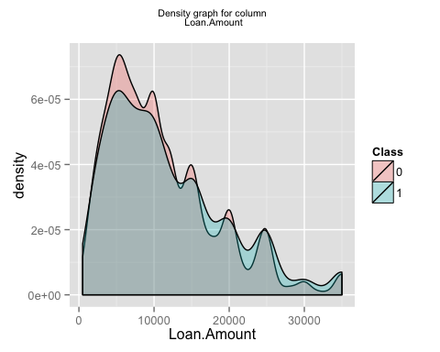

## [1] "generating graph for the column Loan.Term"

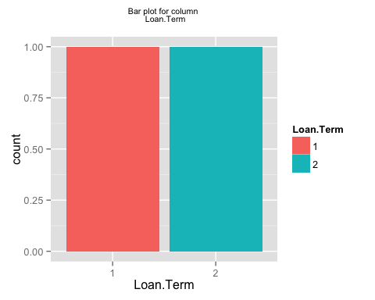

## [1] "generating graph for the column Employment.Length"

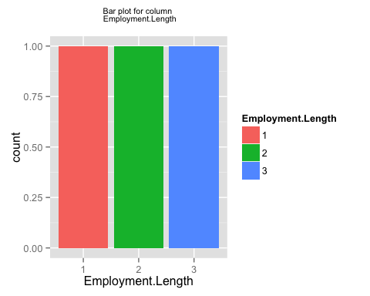

## [1] "generating graph for the column Home.Ownership"

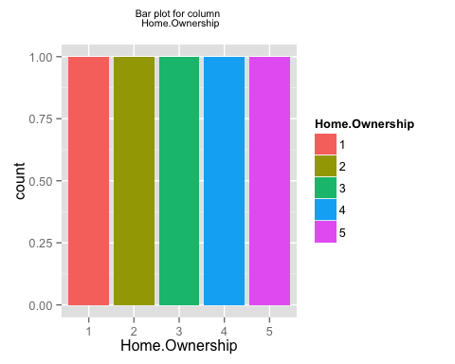

## [1] "generating graph for the column Annual.Income"

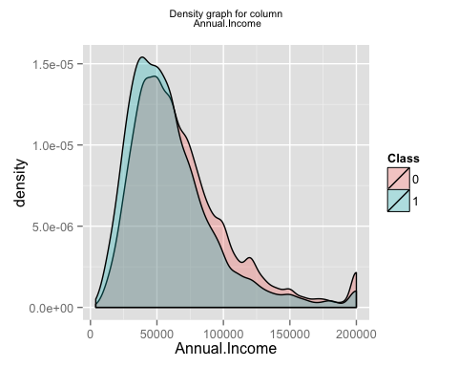

## [1] "generating graph for the column Loan.Purpose"

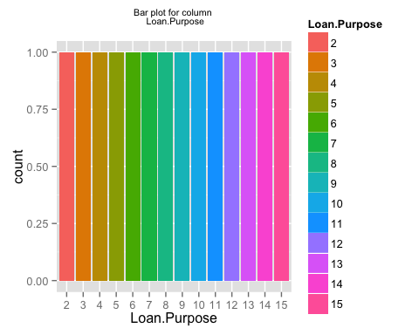

## [1] "generating graph for the column Address.State"

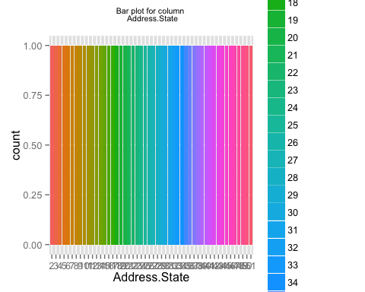

## [1] "generating graph for the column Debt.To.Income.Ratio"

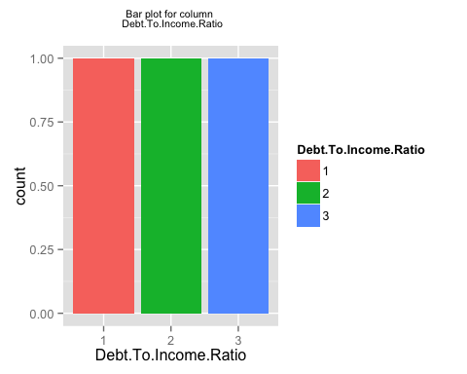

## [1] "generating graph for the column No..Delinquencies.In.Last.2.Years"

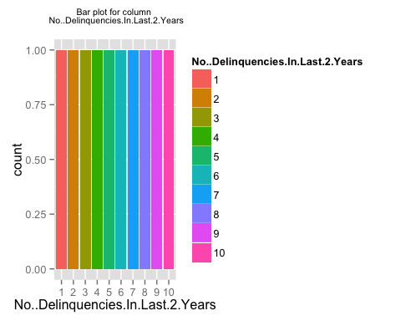

## [1] "generating graph for the column Earliest.Credit.Line.Opened"

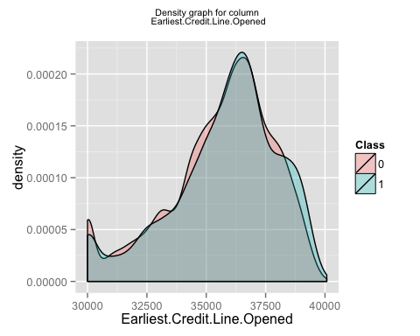

## [1] "generating graph for the column FICO.Credit.Score"

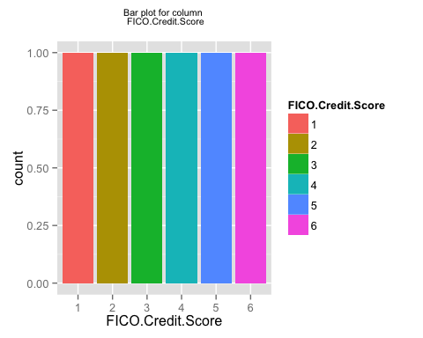

## [1] "generating graph for the column No..Inquiries.In.Last.6.Months"

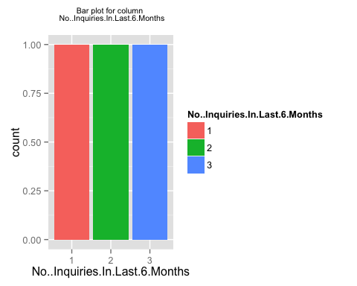

## [1] "generating graph for the column Months.Since.Last.Delinquency"

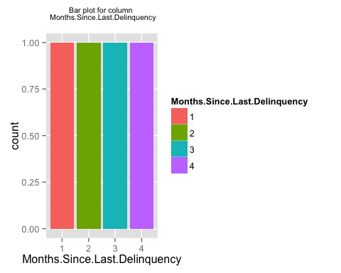

## [1] "generating graph for the column No..Of.Credit.Lines"

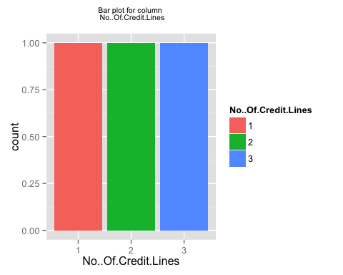

## [1] "generating graph for the column No..Adverse.Public.Records"

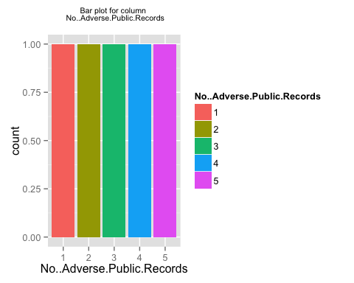

## [1] "generating graph for the column Total.Credit.Balance"

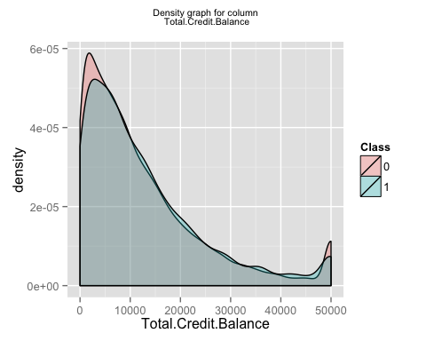

## [1] "generating graph for the column Use.Of.Credit.Line"

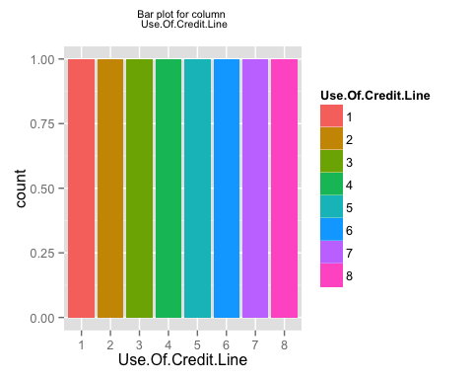

## [1] "generating graph for the column Total.Number.Of.Credit.Lines"

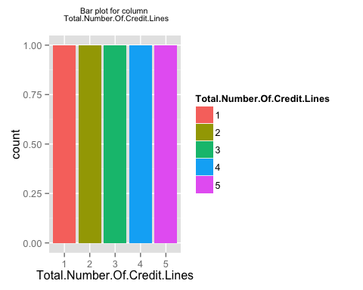

## [1] "generating graph for the column Loan.Application.Description"

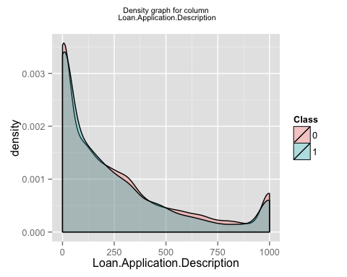

## [1] "generating graph for the column No..Of.Public.Record.Bankruptcies"

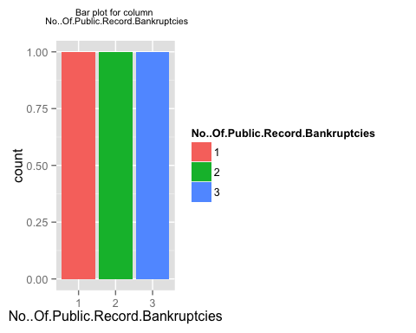

## [1] "generating graph for the column Class"

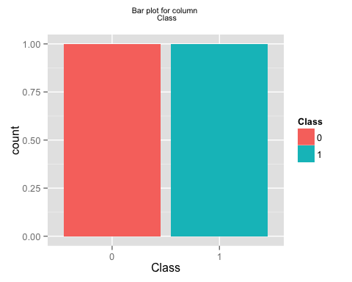

## [1] "finished generating the first set of plots i.e. individual plots for each column"  
## [1] "now generating the second set of plots i.e. plots for a pair of columns"

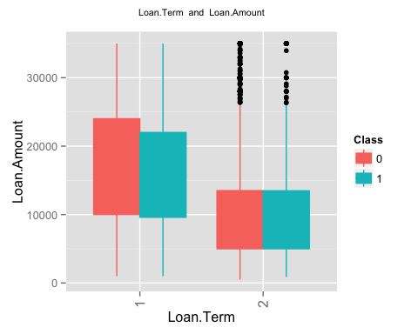 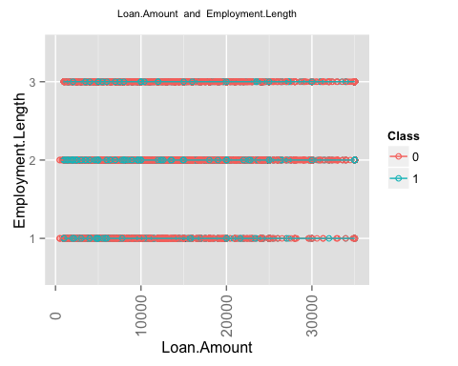 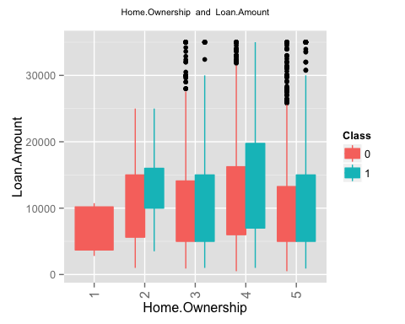 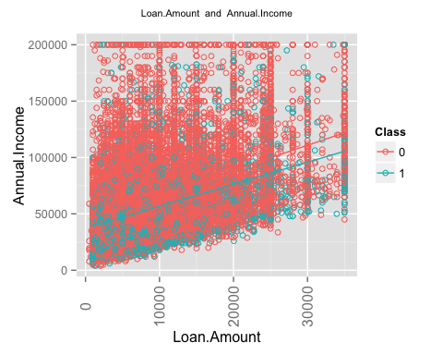 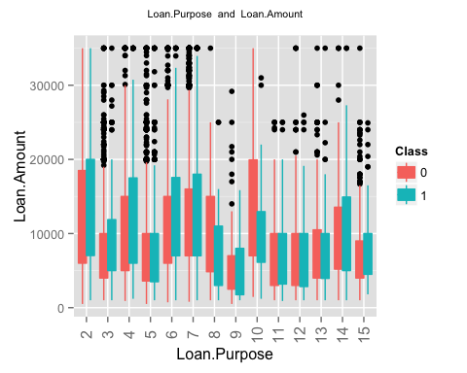 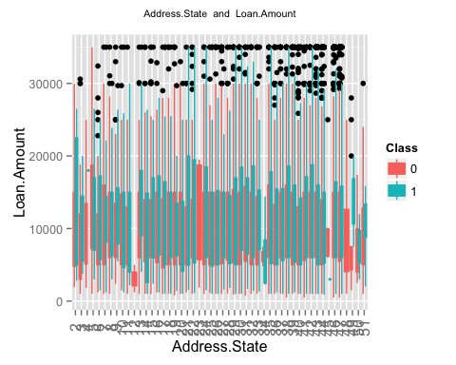 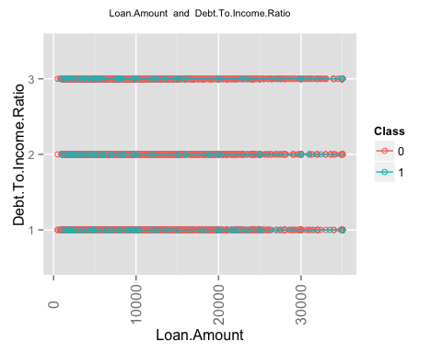 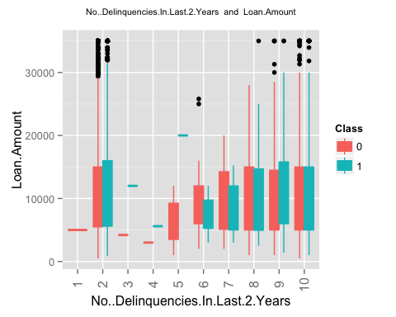 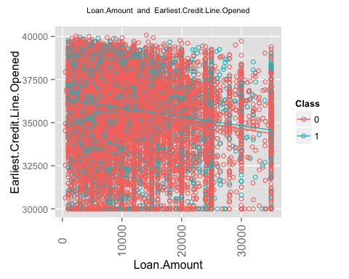 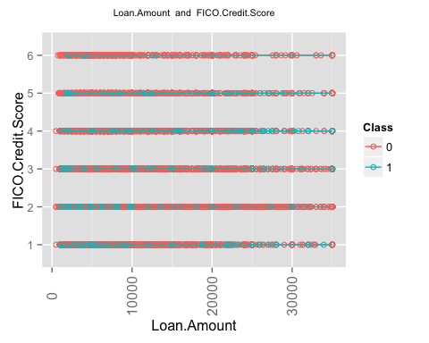 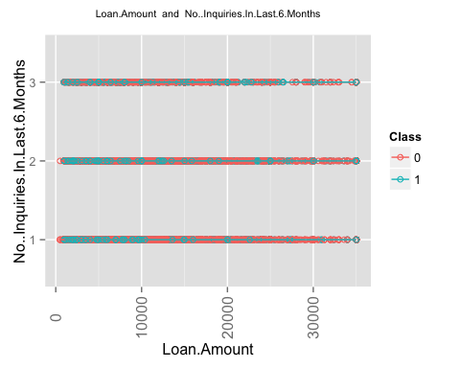 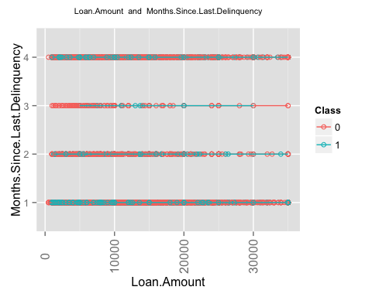 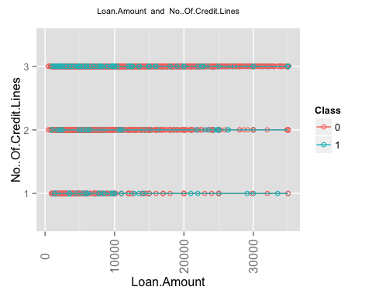 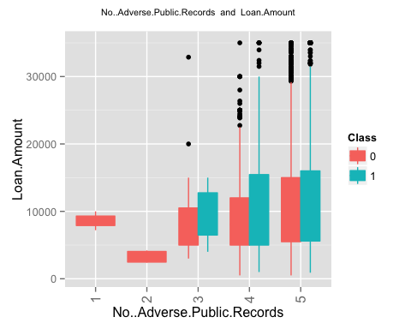 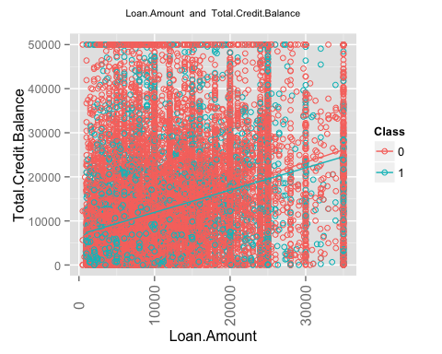 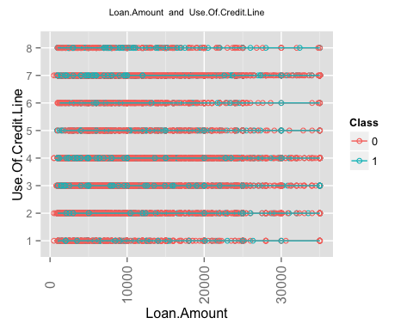 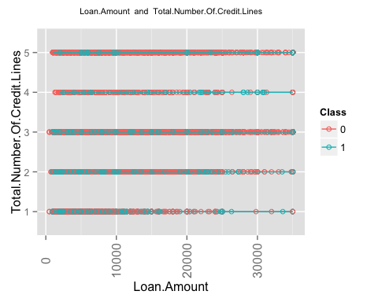 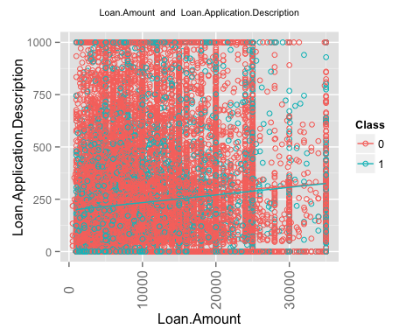 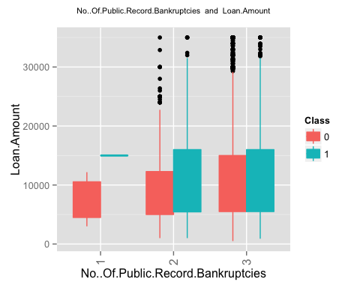 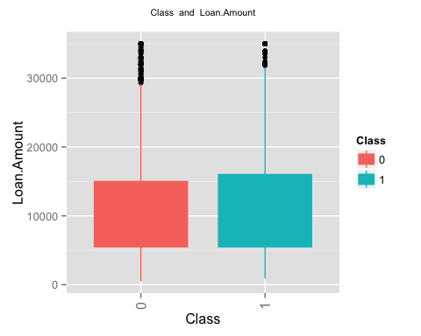 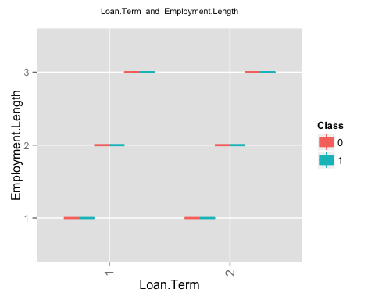 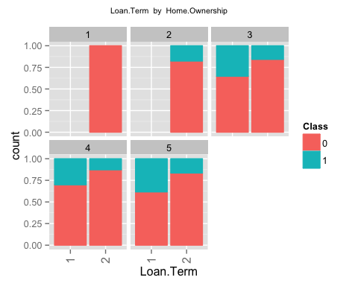 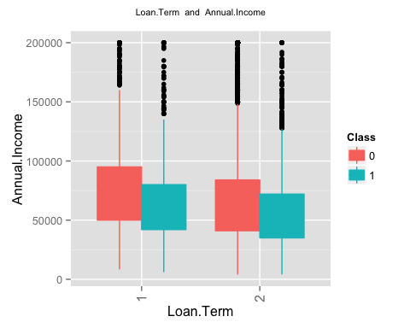 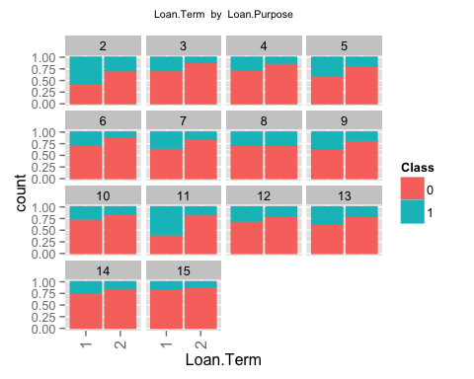 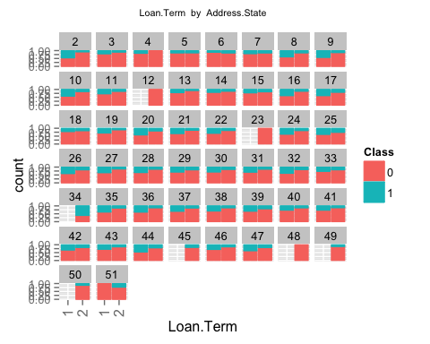 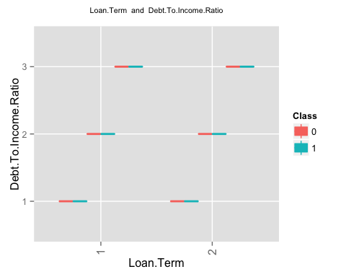 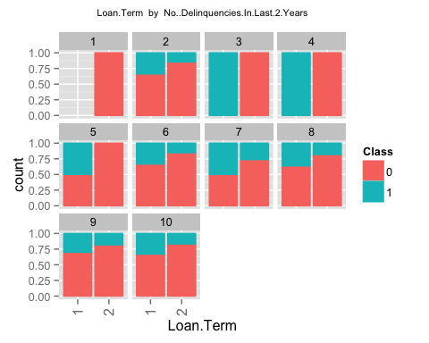 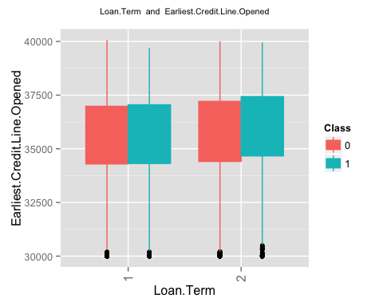 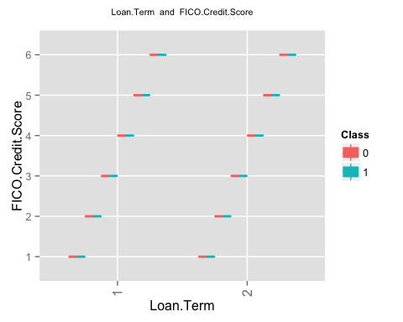 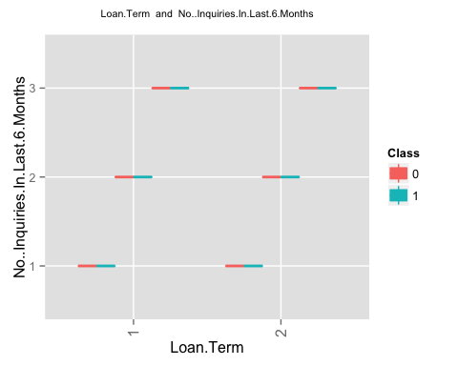 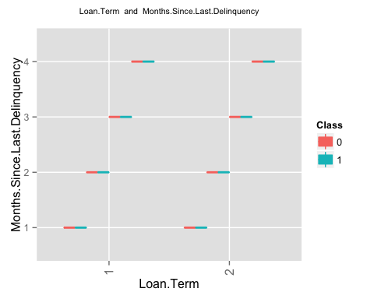 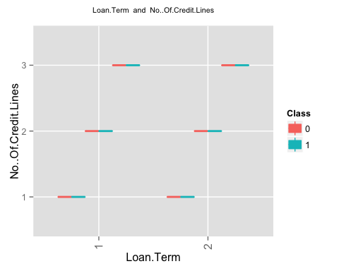 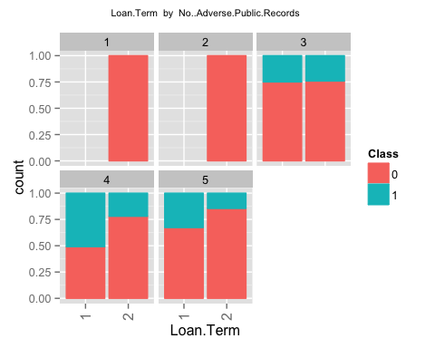 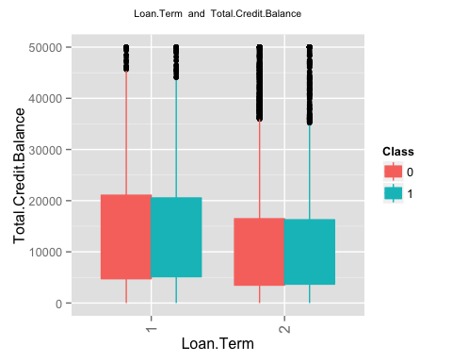 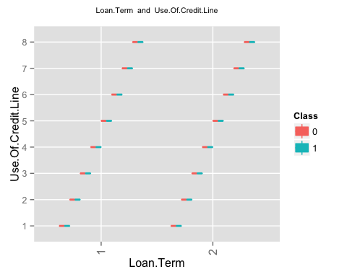 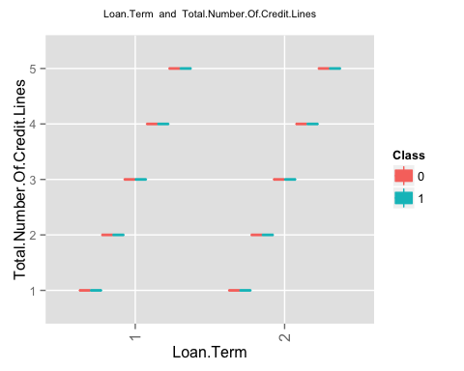 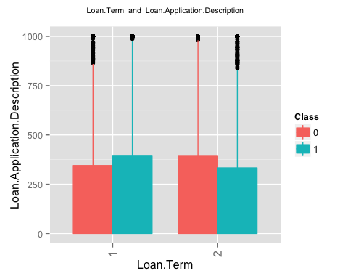 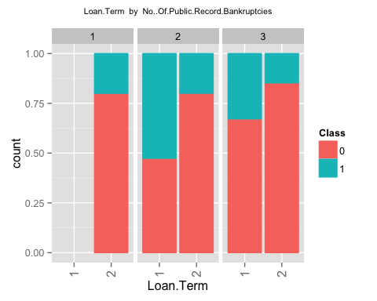 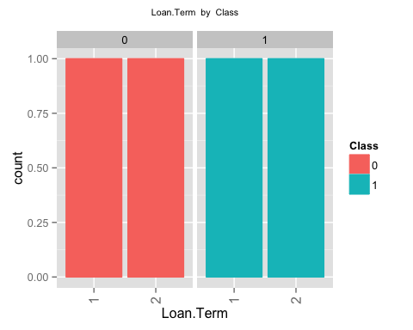 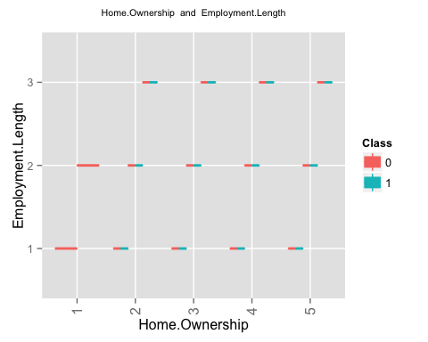

## geom_smooth: Only one unique x value each group.Maybe you want aes(group = 1)?

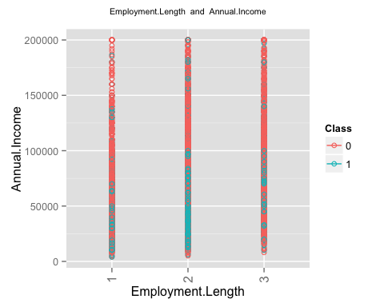 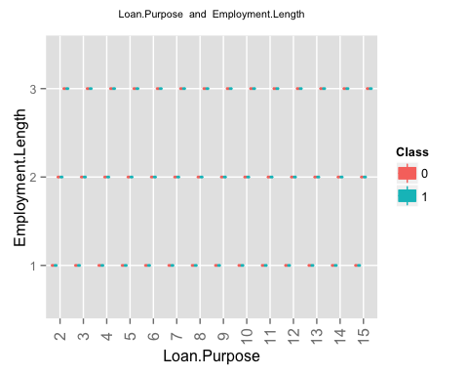 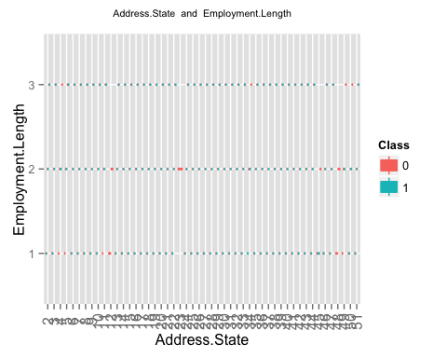

## geom_smooth: Only one unique x value each group.Maybe you want aes(group = 1)?

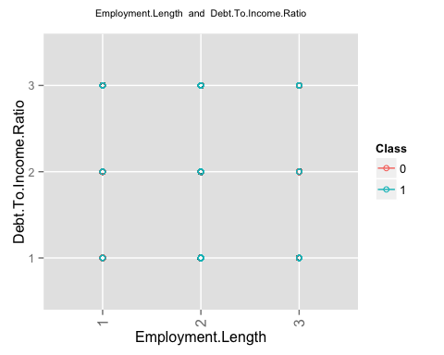 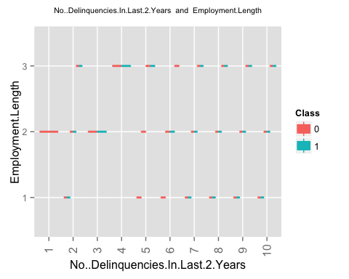

## geom_smooth: Only one unique x value each group.Maybe you want aes(group = 1)?

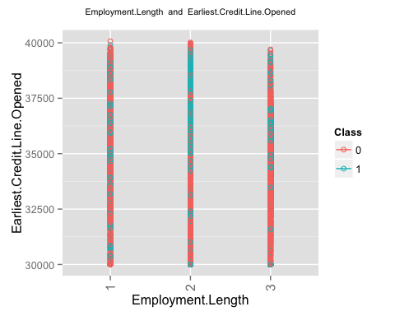

## geom_smooth: Only one unique x value each group.Maybe you want aes(group = 1)?

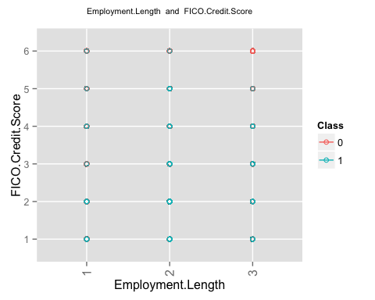

## geom_smooth: Only one unique x value each group.Maybe you want aes(group = 1)?

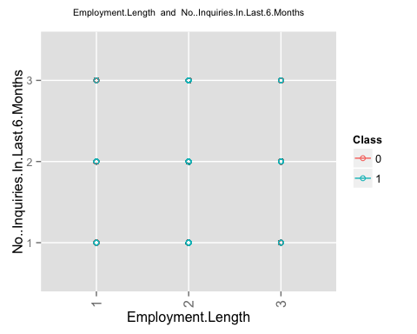

## geom_smooth: Only one unique x value each group.Maybe you want aes(group = 1)?

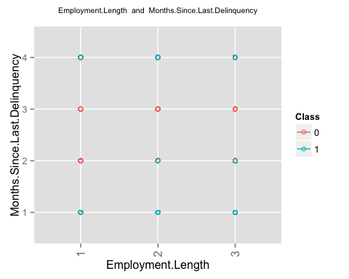

## geom_smooth: Only one unique x value each group.Maybe you want aes(group = 1)?

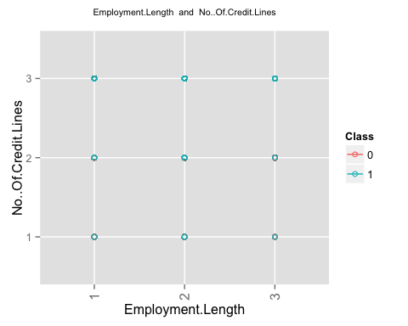 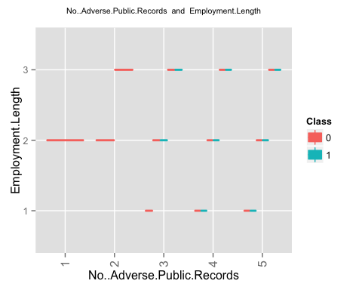

## geom_smooth: Only one unique x value each group.Maybe you want aes(group = 1)?

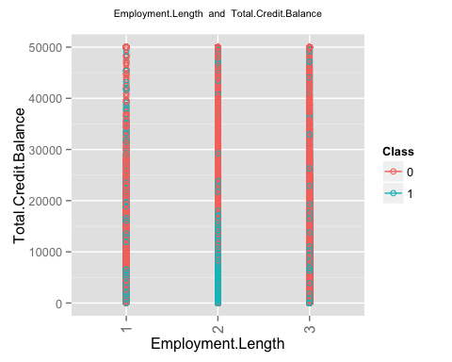

## geom_smooth: Only one unique x value each group.Maybe you want aes(group = 1)?

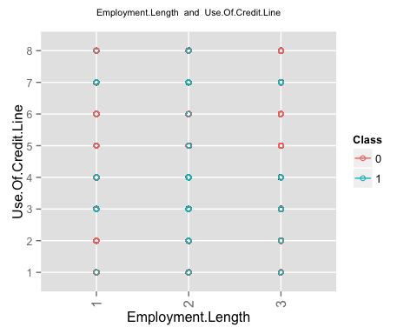

## geom_smooth: Only one unique x value each group.Maybe you want aes(group = 1)?

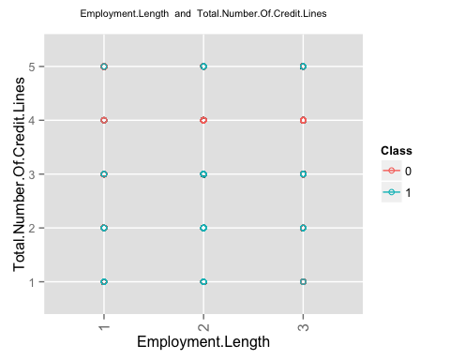

## geom_smooth: Only one unique x value each group.Maybe you want aes(group = 1)?

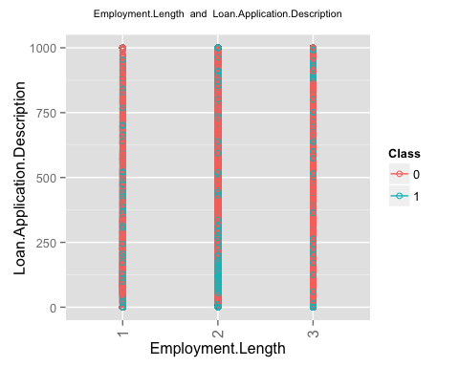 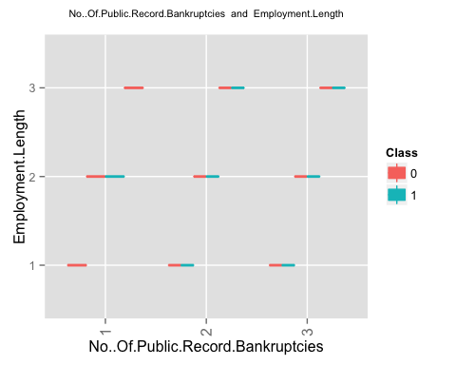 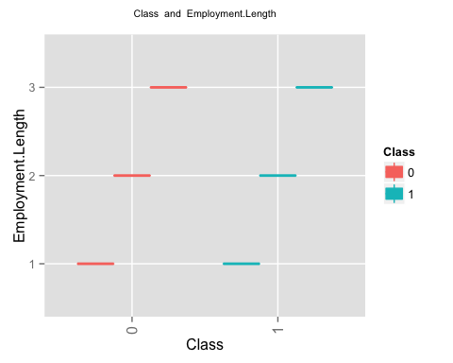 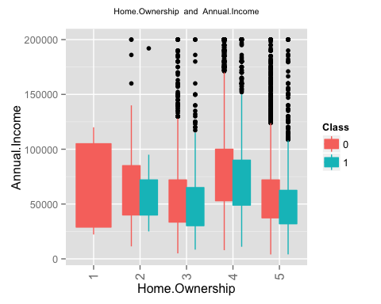 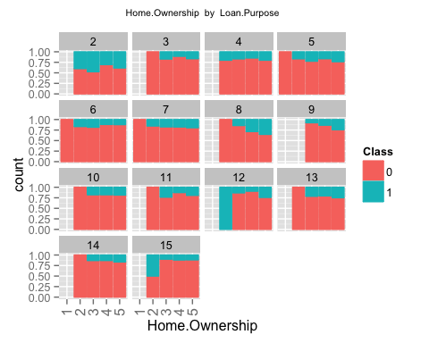 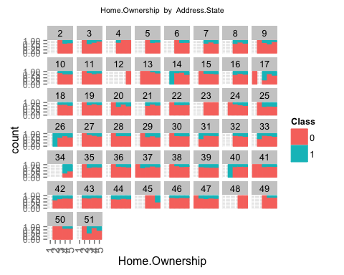 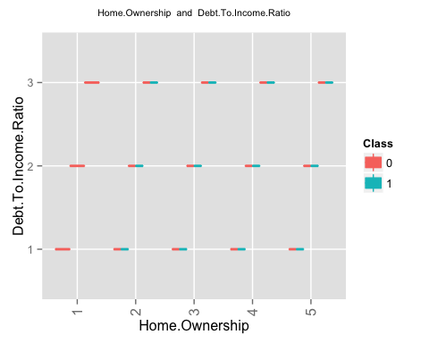 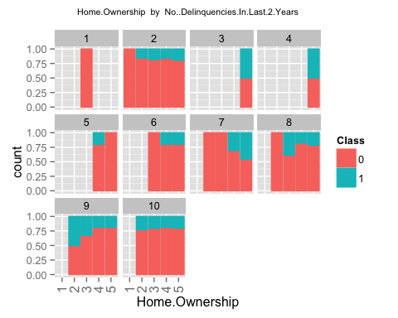 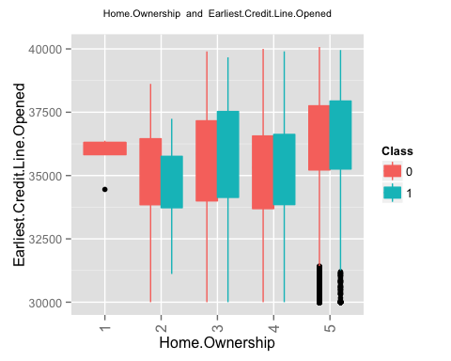 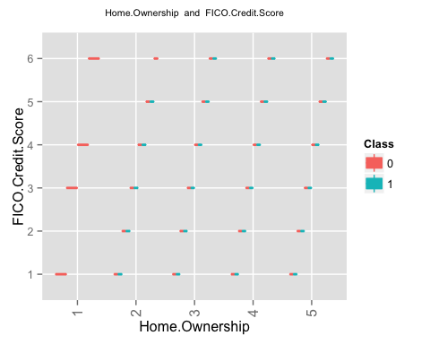 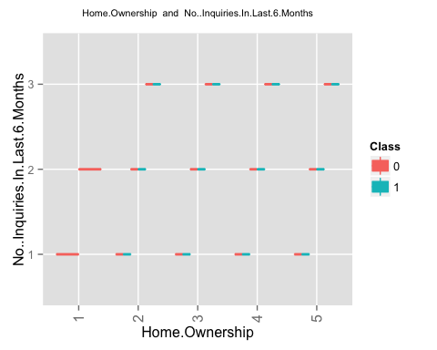 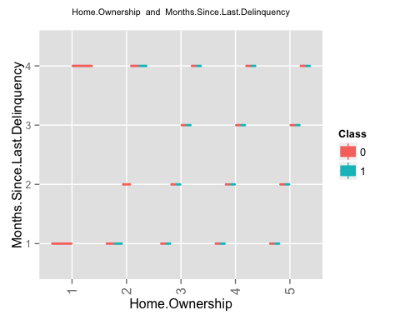 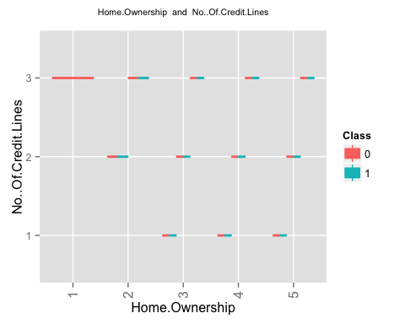 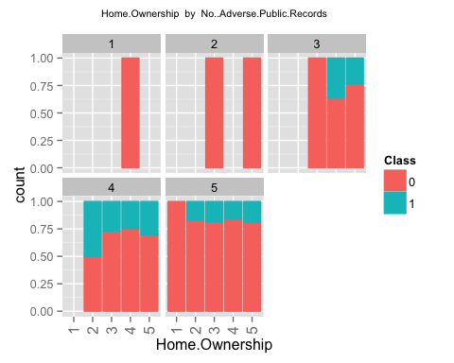 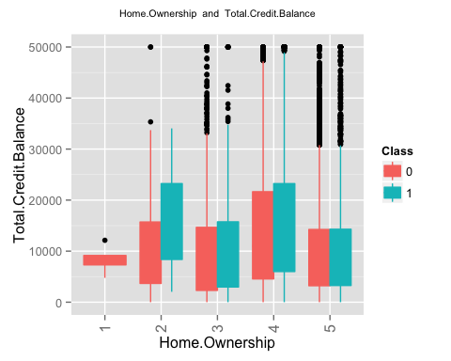 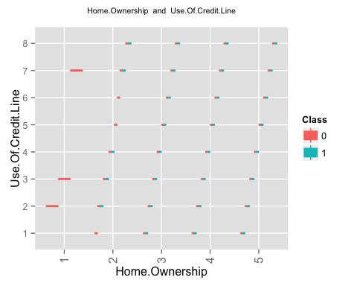 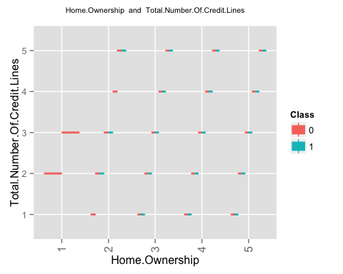 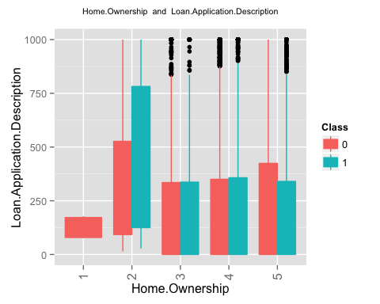 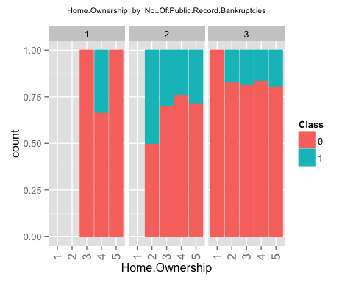 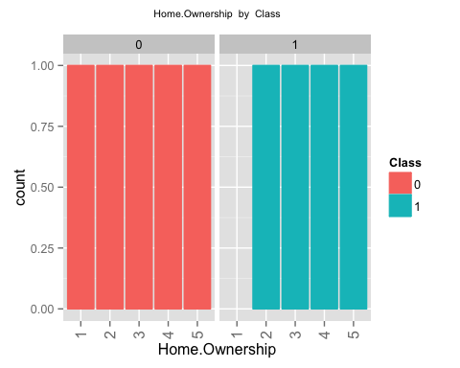 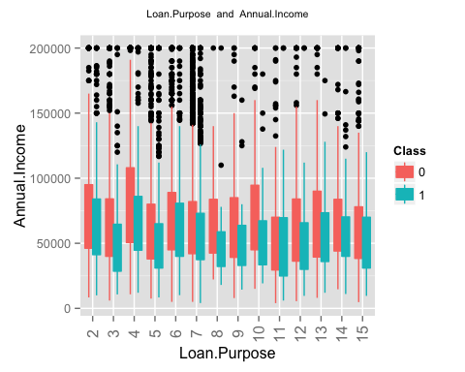 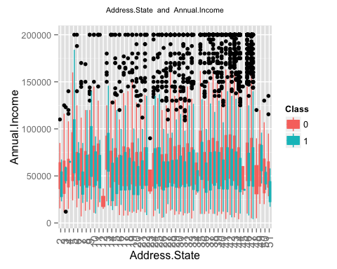 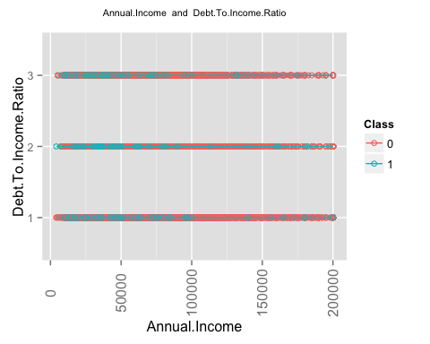 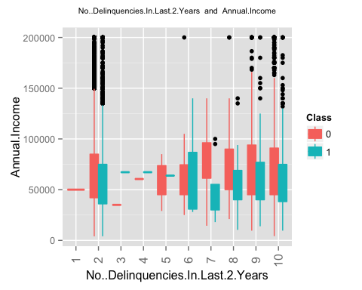 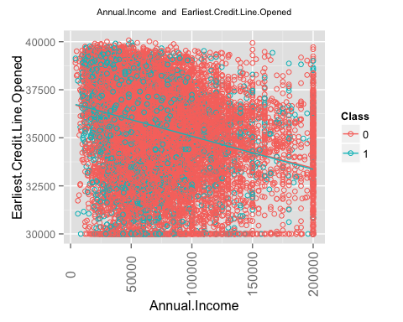 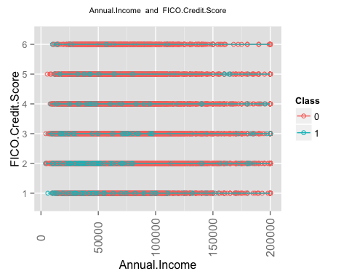 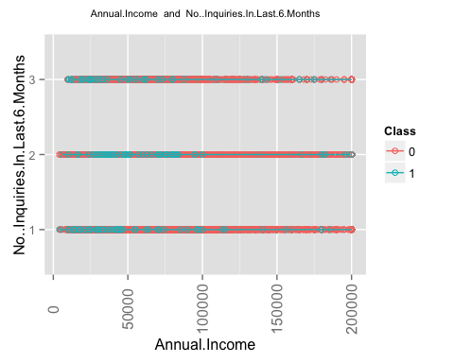 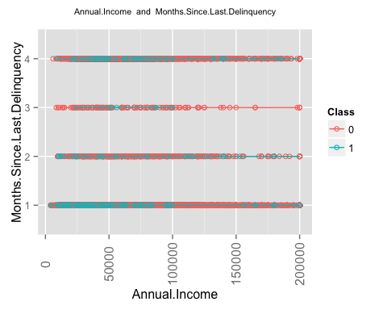 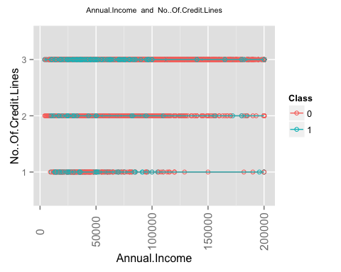 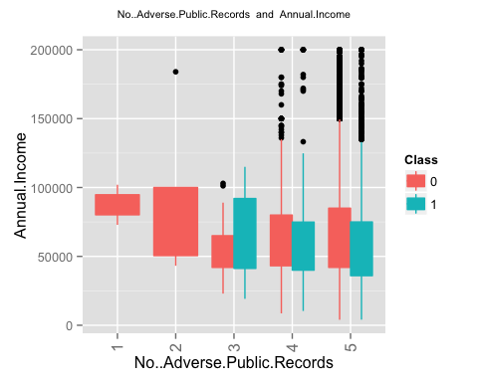 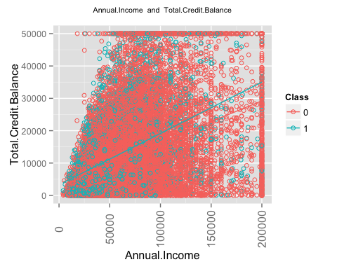 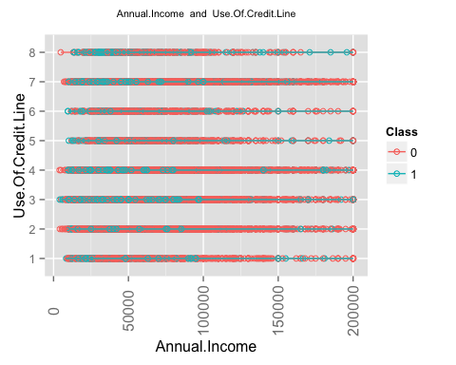 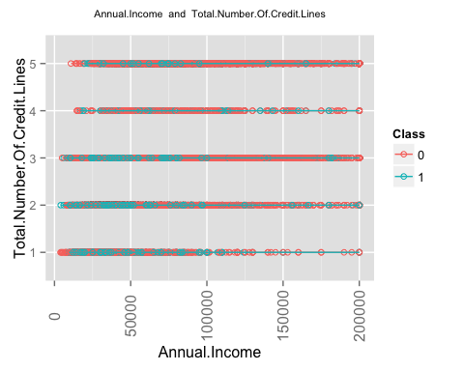 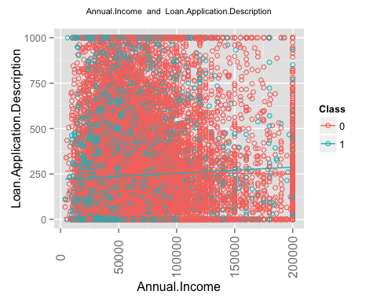 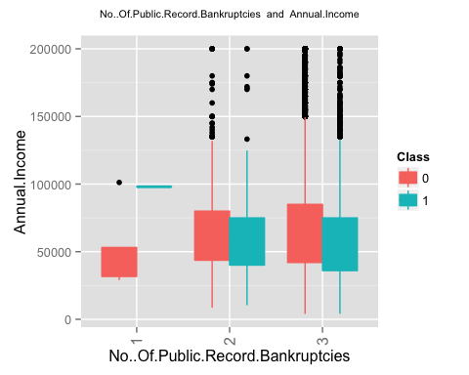 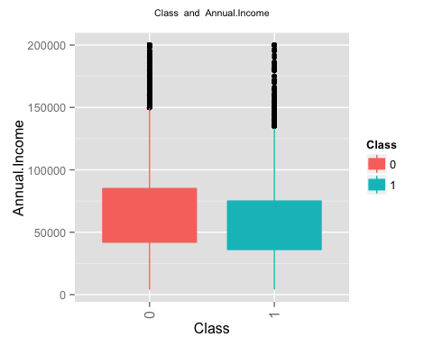 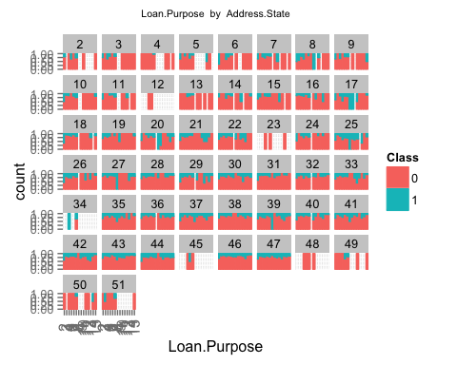 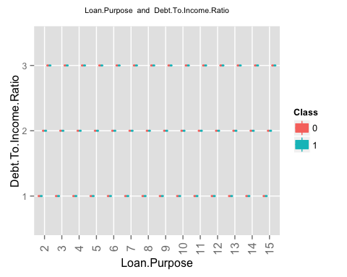 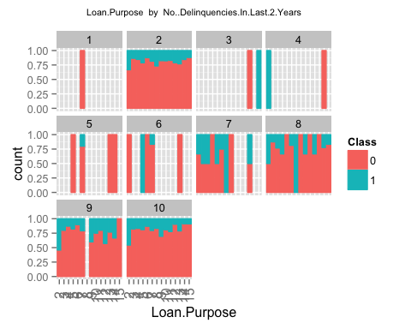 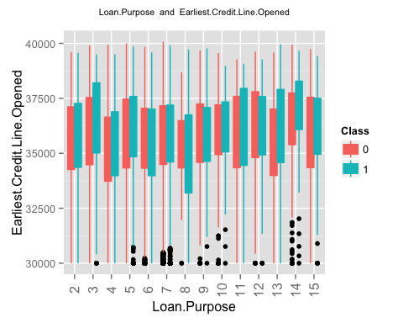 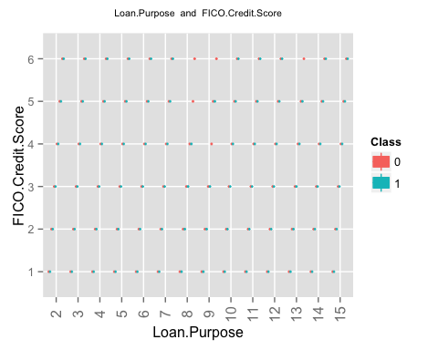 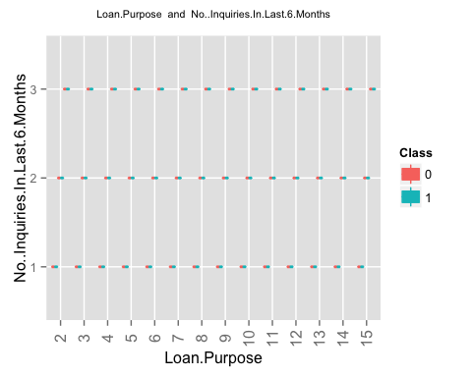 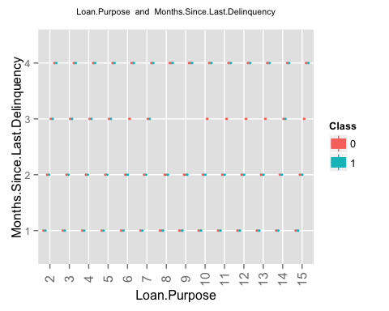 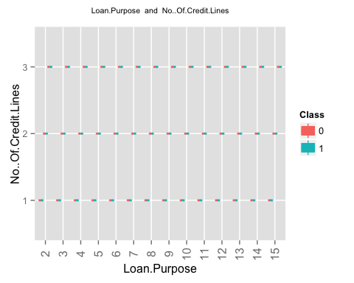 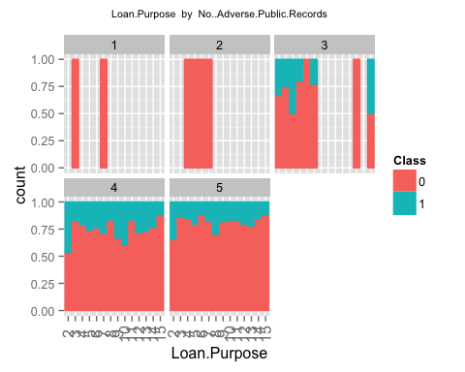 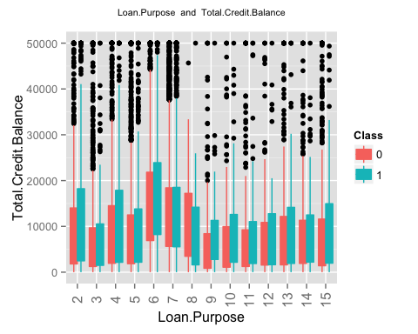 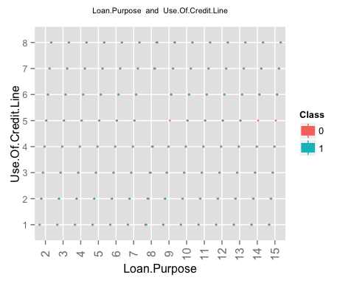 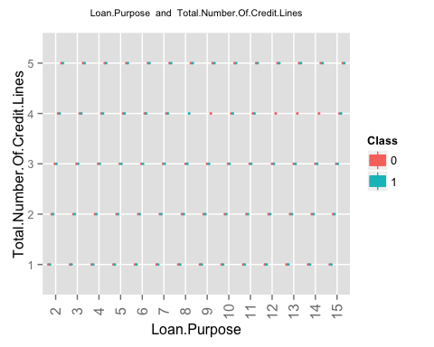 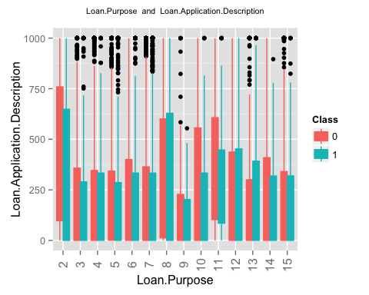 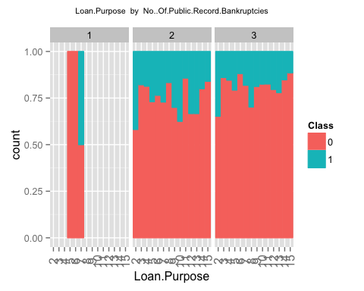 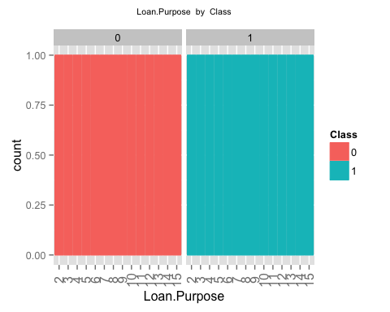 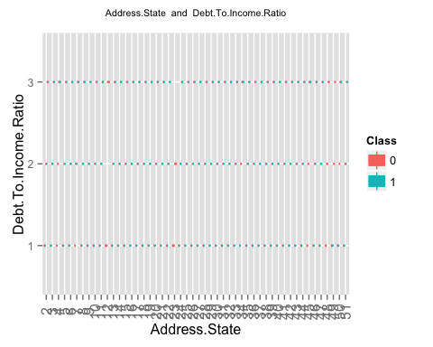 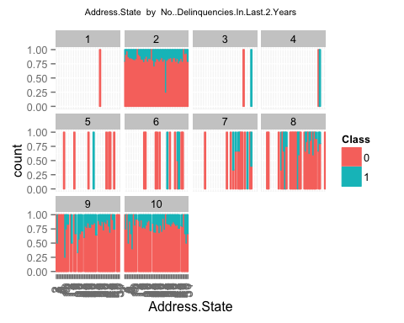 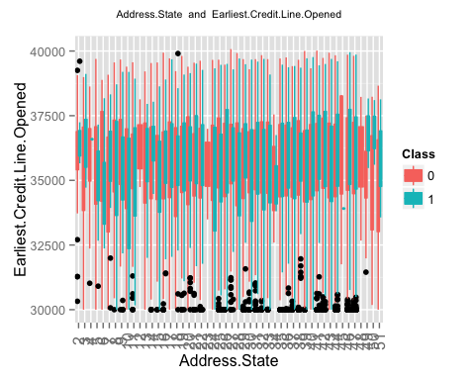 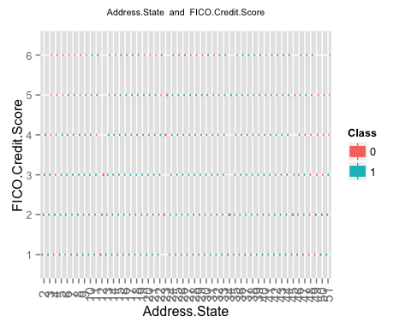 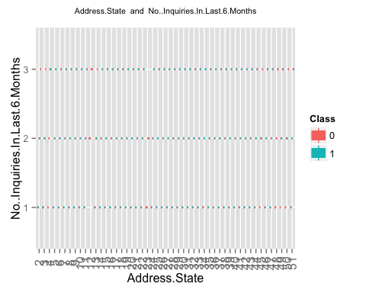 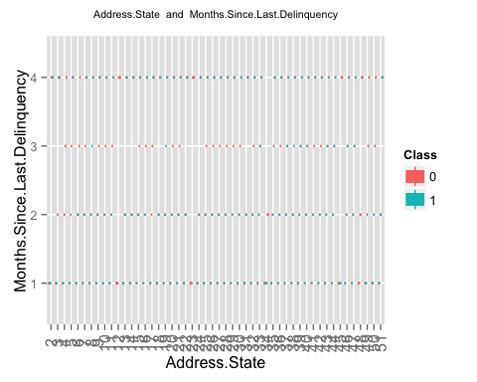 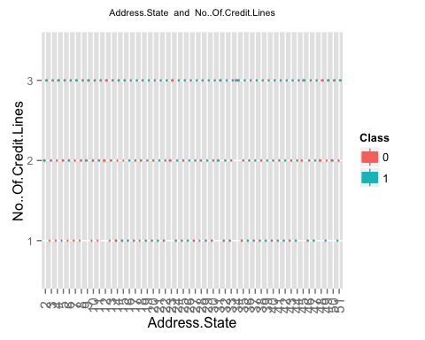 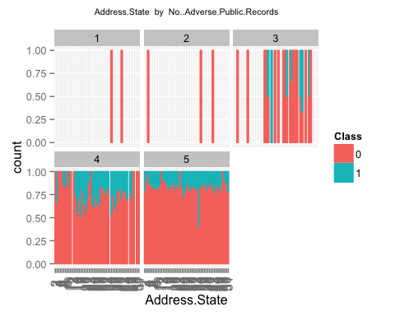 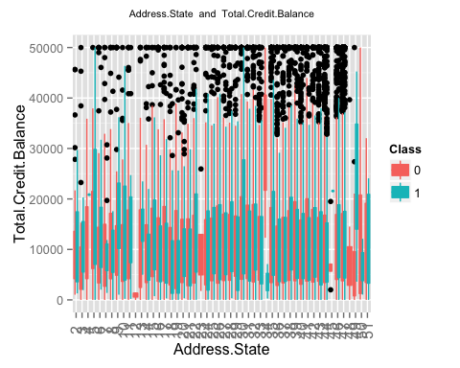 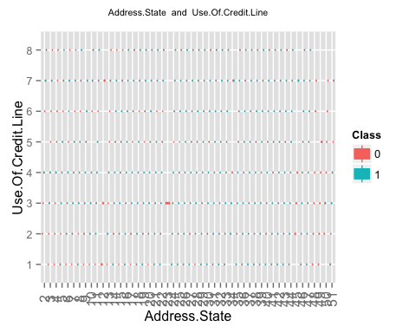 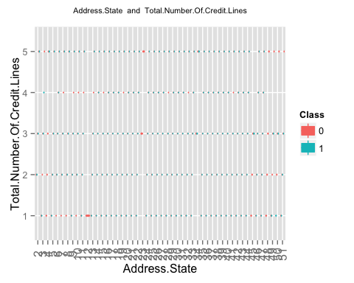 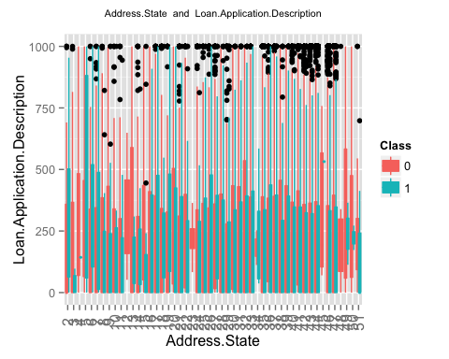 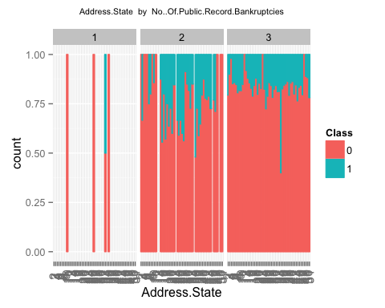 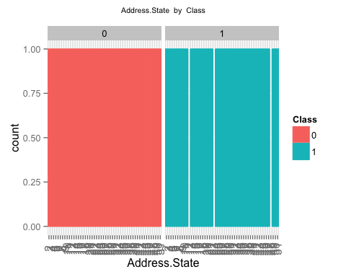 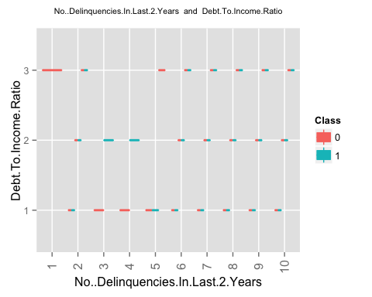

## geom_smooth: Only one unique x value each group.Maybe you want aes(group = 1)?

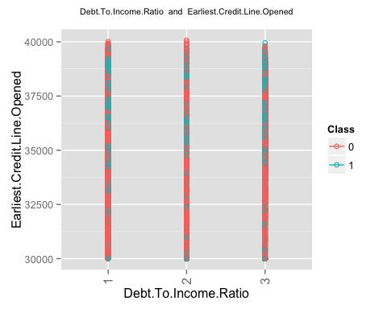

## geom_smooth: Only one unique x value each group.Maybe you want aes(group = 1)?

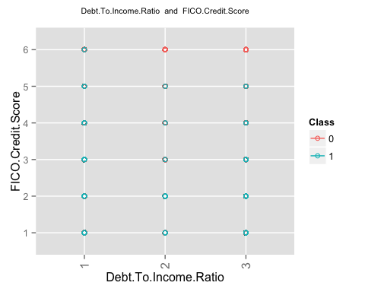

## geom_smooth: Only one unique x value each group.Maybe you want aes(group = 1)?

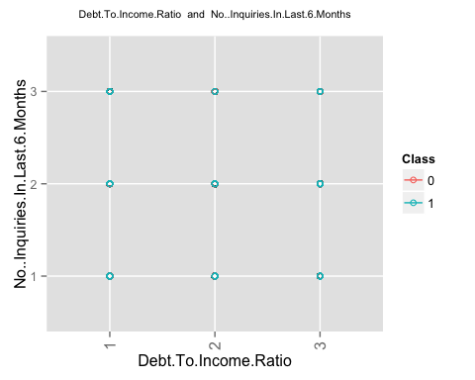

## geom_smooth: Only one unique x value each group.Maybe you want aes(group = 1)?

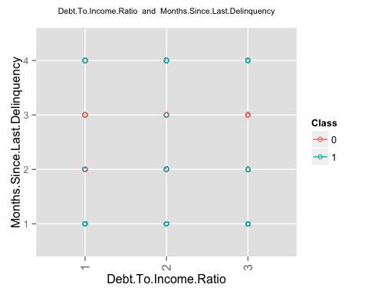

## geom_smooth: Only one unique x value each group.Maybe you want aes(group = 1)?

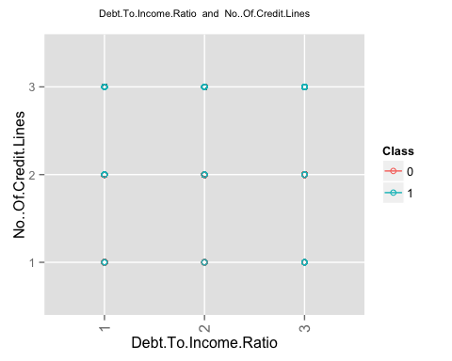 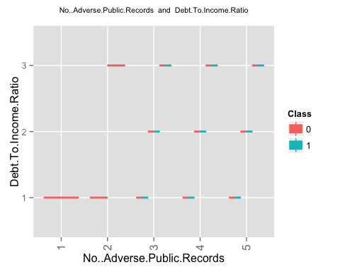

## geom_smooth: Only one unique x value each group.Maybe you want aes(group = 1)?

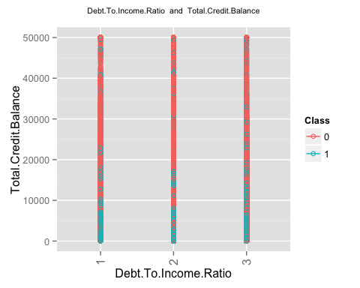

## geom_smooth: Only one unique x value each group.Maybe you want aes(group = 1)?

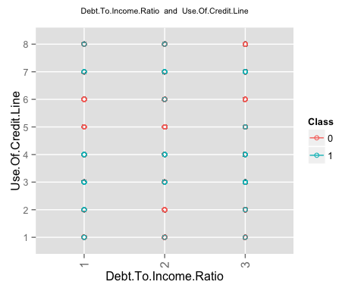

## geom_smooth: Only one unique x value each group.Maybe you want aes(group = 1)?

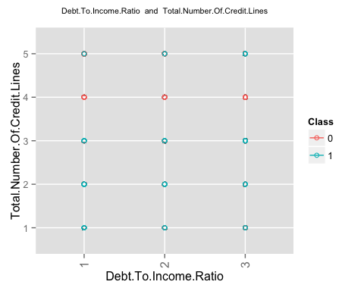

## geom_smooth: Only one unique x value each group.Maybe you want aes(group = 1)?

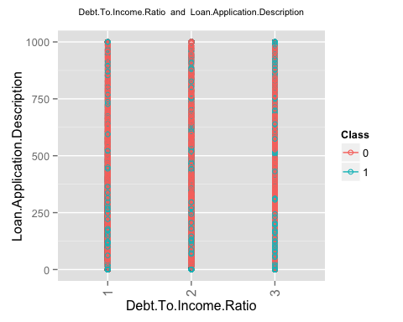 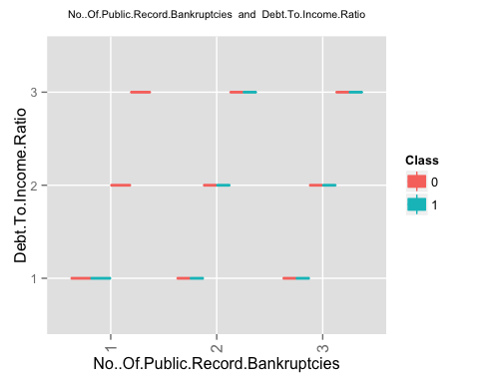 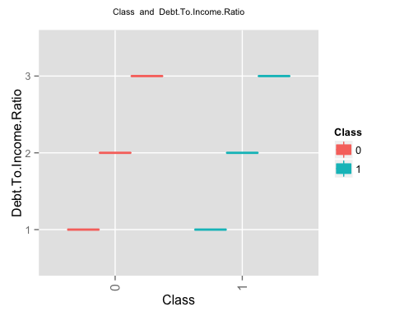 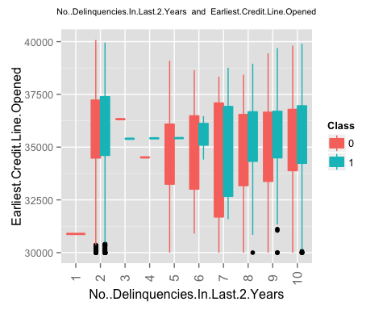 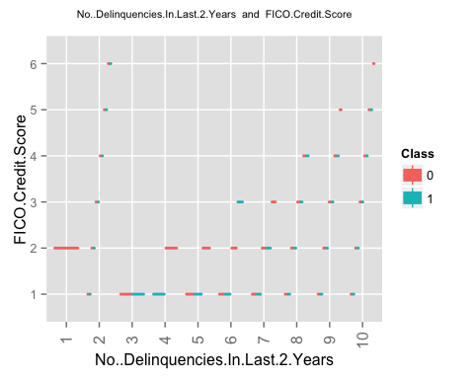 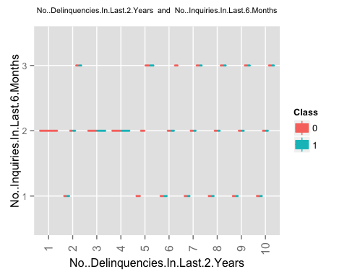 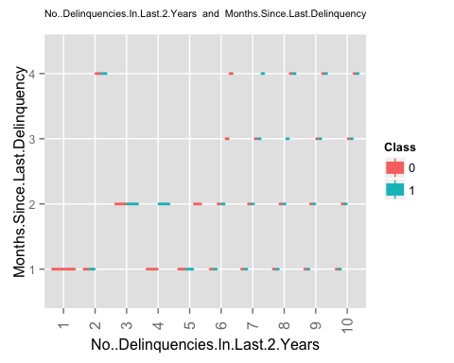 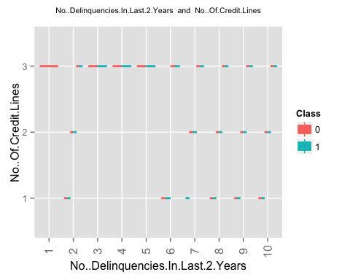 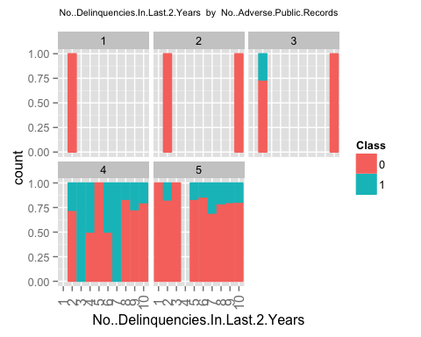 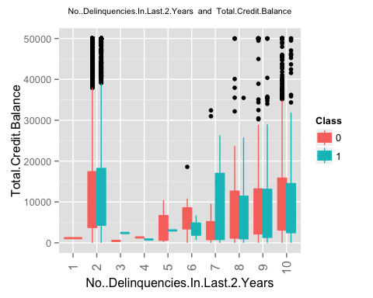 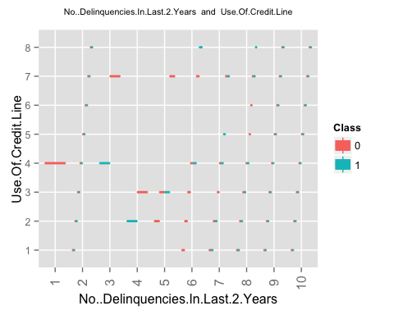 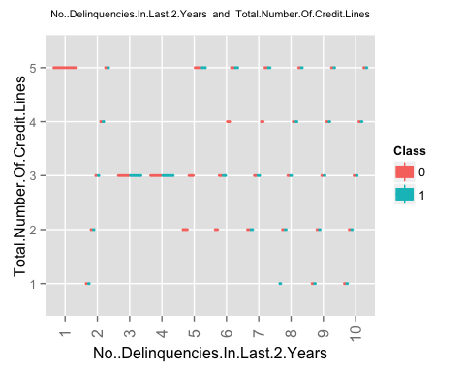 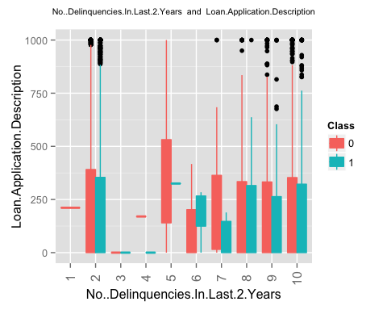 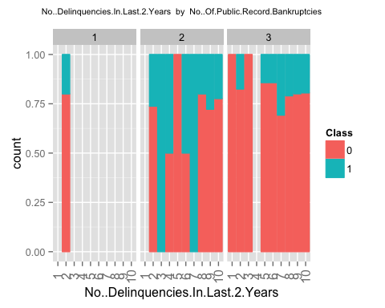 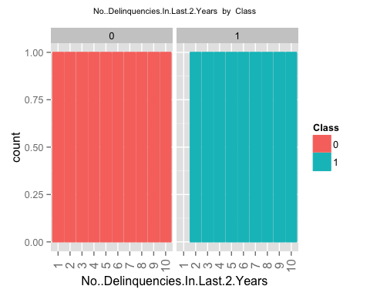 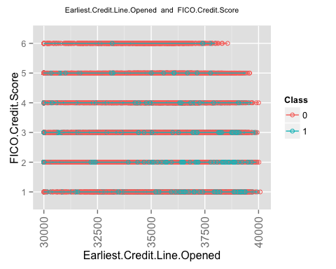 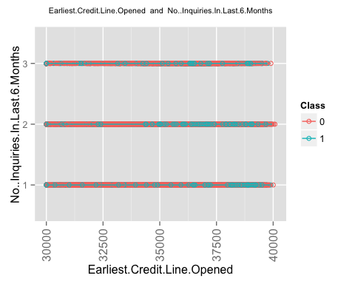 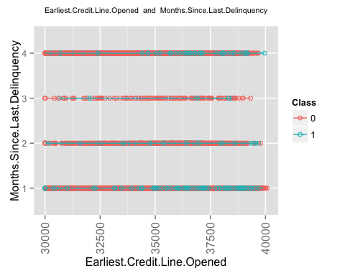 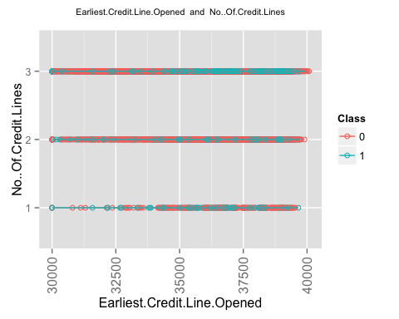 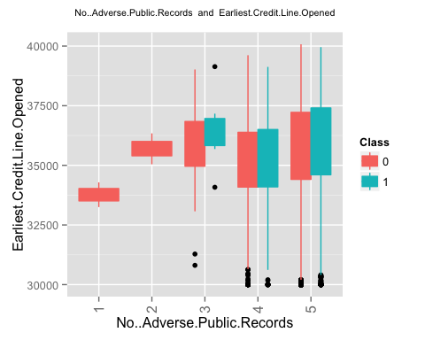 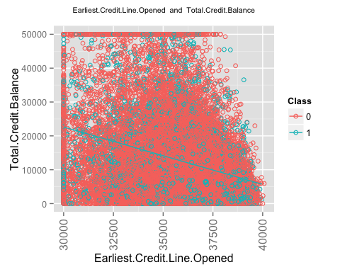 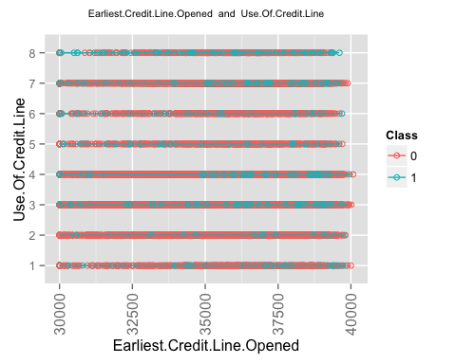 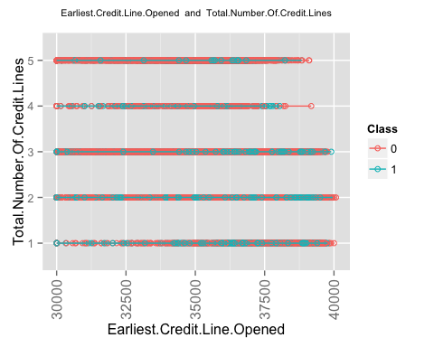 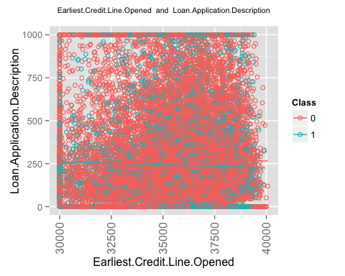 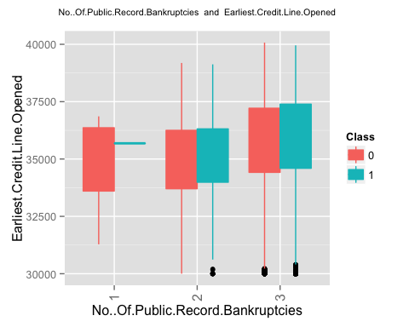 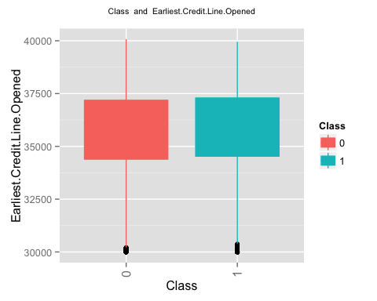

## geom_smooth: Only one unique x value each group.Maybe you want aes(group = 1)?

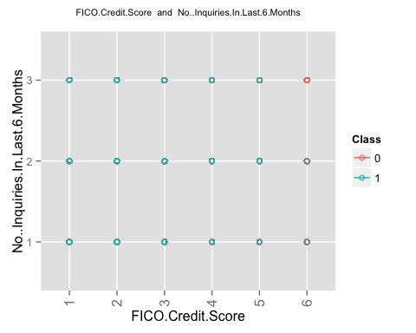

## geom_smooth: Only one unique x value each group.Maybe you want aes(group = 1)?

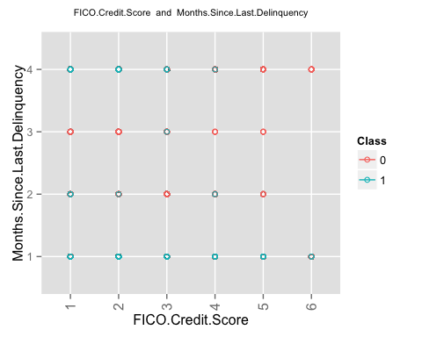

## geom_smooth: Only one unique x value each group.Maybe you want aes(group = 1)?

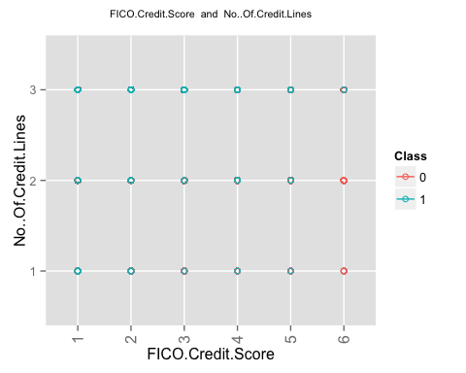 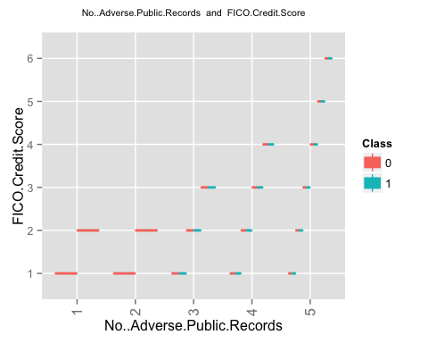

## geom_smooth: Only one unique x value each group.Maybe you want aes(group = 1)?

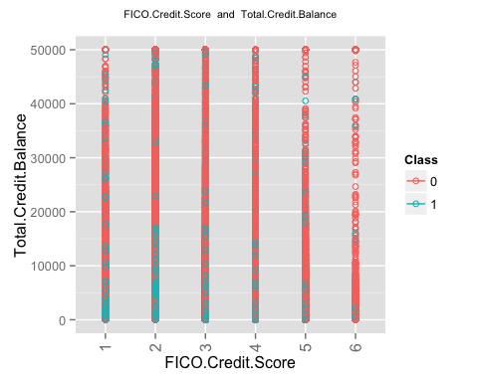

## geom_smooth: Only one unique x value each group.Maybe you want aes(group = 1)?

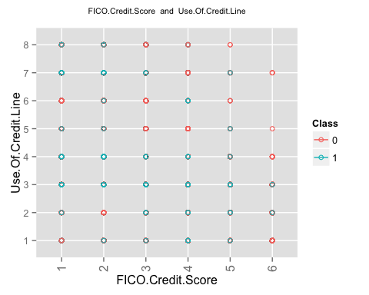

## geom_smooth: Only one unique x value each group.Maybe you want aes(group = 1)?

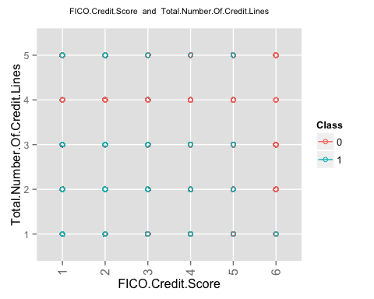

## geom_smooth: Only one unique x value each group.Maybe you want aes(group = 1)?

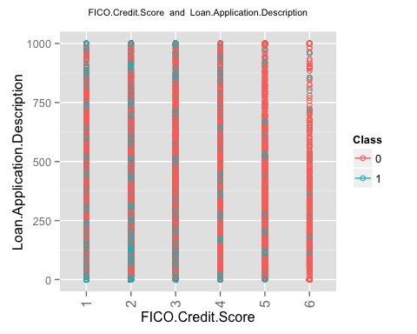 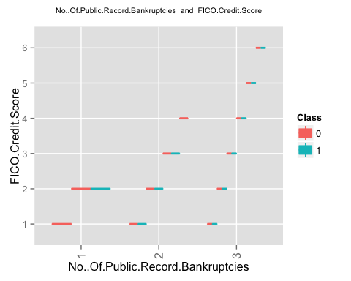 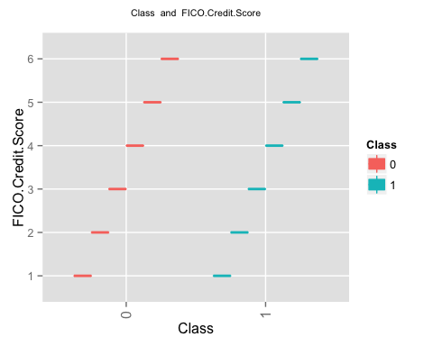

## geom_smooth: Only one unique x value each group.Maybe you want aes(group = 1)?

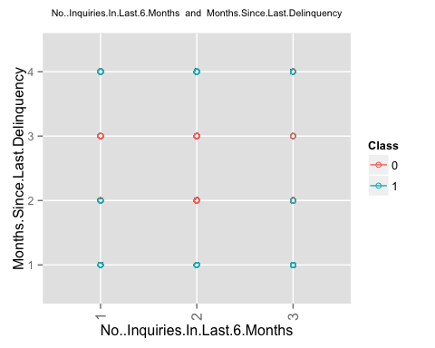

## geom_smooth: Only one unique x value each group.Maybe you want aes(group = 1)?

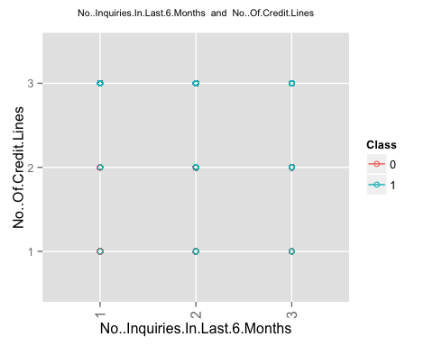 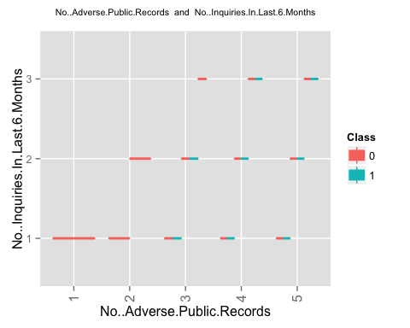

## geom_smooth: Only one unique x value each group.Maybe you want aes(group = 1)?

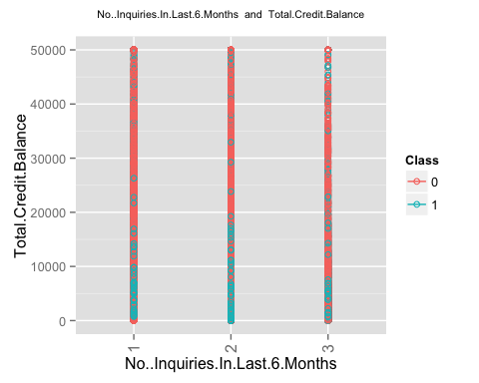

## geom_smooth: Only one unique x value each group.Maybe you want aes(group = 1)?

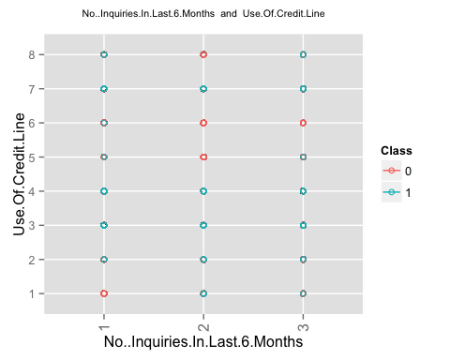

## geom_smooth: Only one unique x value each group.Maybe you want aes(group = 1)?

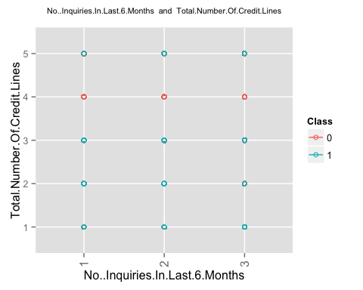

## geom_smooth: Only one unique x value each group.Maybe you want aes(group = 1)?

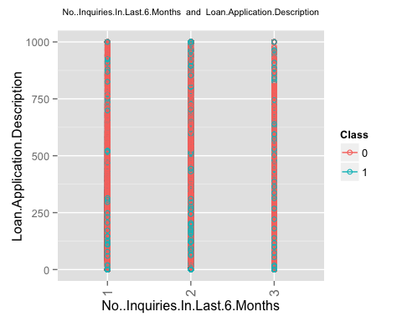 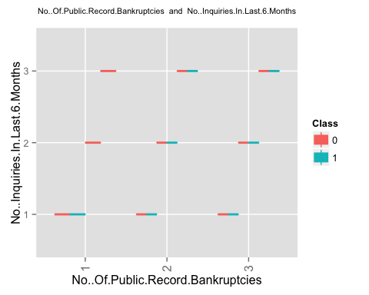 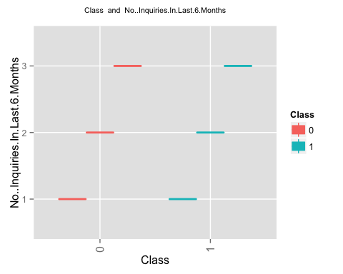

## geom_smooth: Only one unique x value each group.Maybe you want aes(group = 1)?

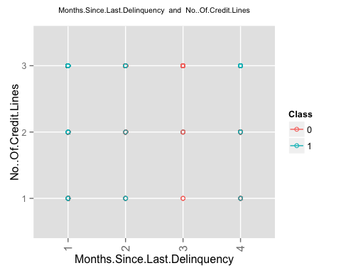 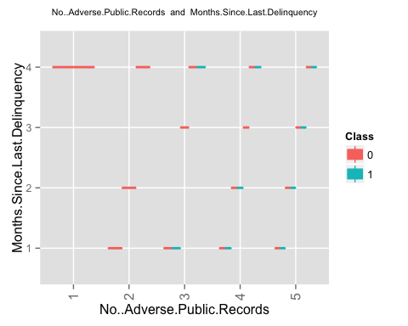

## geom_smooth: Only one unique x value each group.Maybe you want aes(group = 1)?

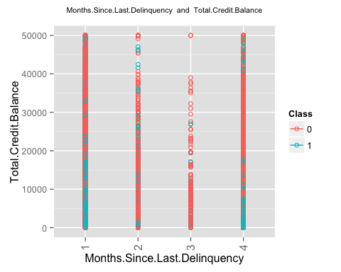

## geom_smooth: Only one unique x value each group.Maybe you want aes(group = 1)?

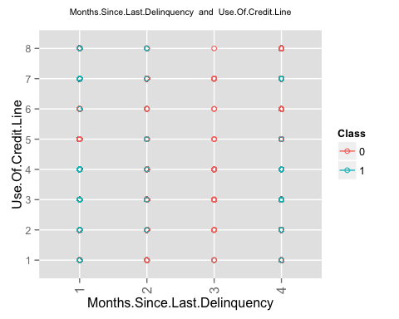

## geom_smooth: Only one unique x value each group.Maybe you want aes(group = 1)?

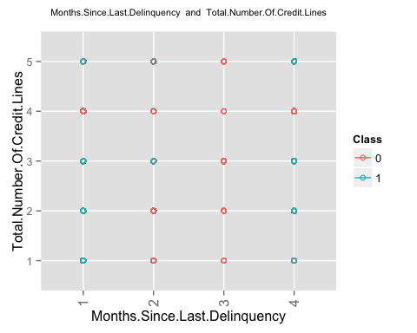

## geom_smooth: Only one unique x value each group.Maybe you want aes(group = 1)?

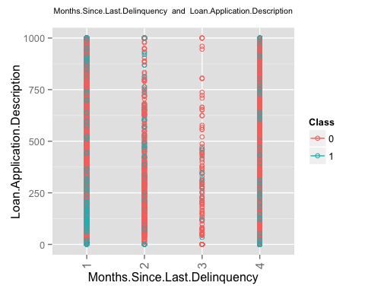 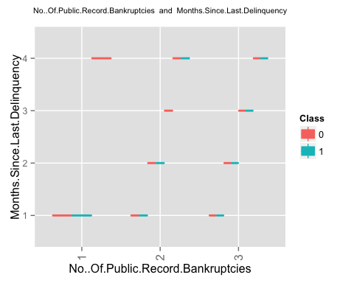 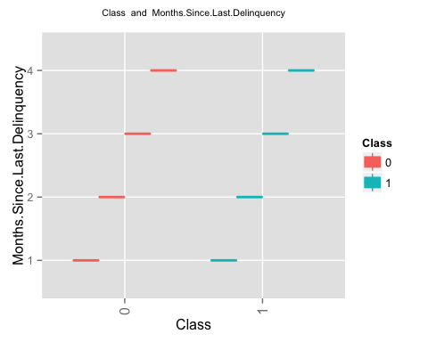 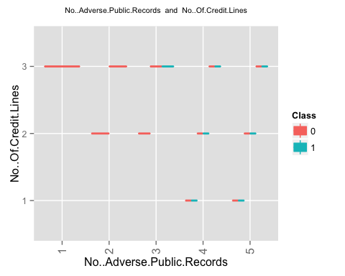

## geom_smooth: Only one unique x value each group.Maybe you want aes(group = 1)?

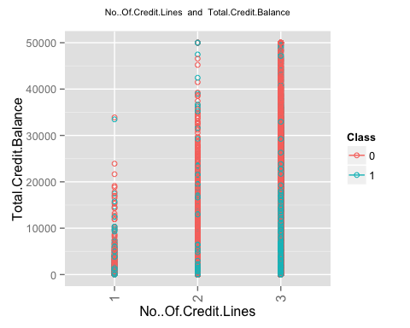

## geom_smooth: Only one unique x value each group.Maybe you want aes(group = 1)?

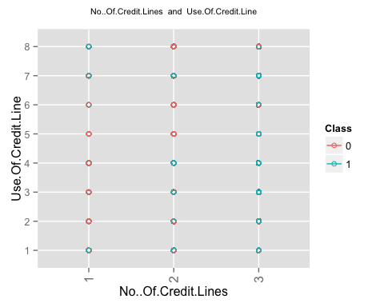

## geom_smooth: Only one unique x value each group.Maybe you want aes(group = 1)?

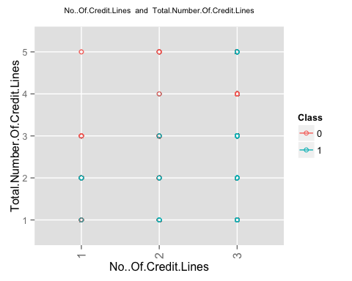

## geom_smooth: Only one unique x value each group.Maybe you want aes(group = 1)?

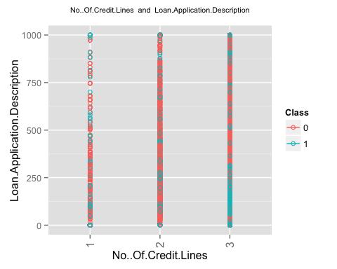 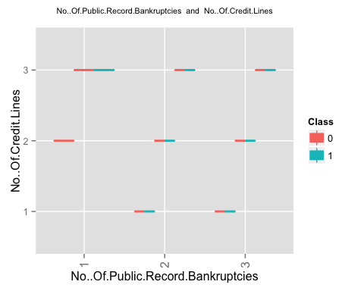 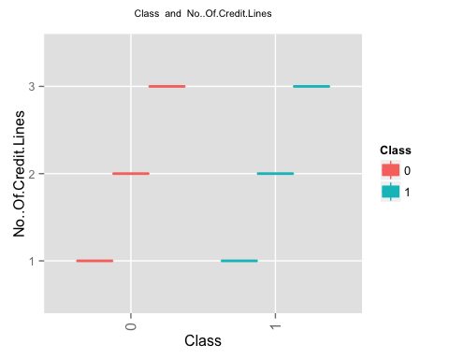 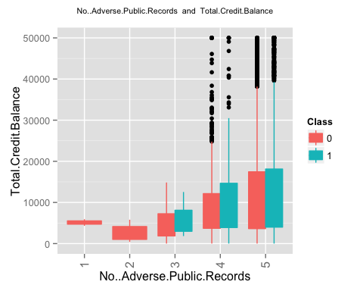 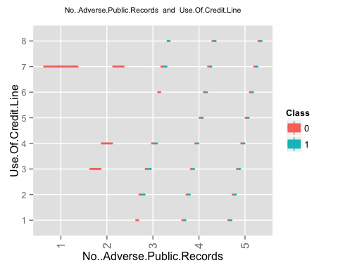 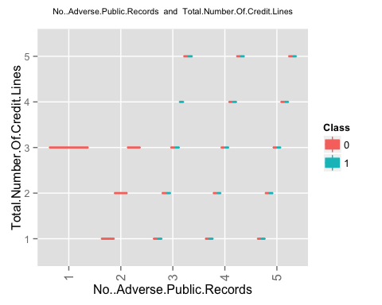 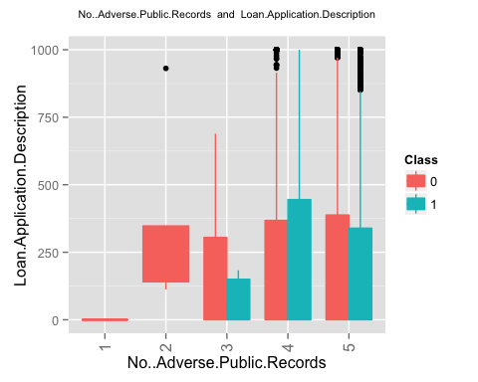 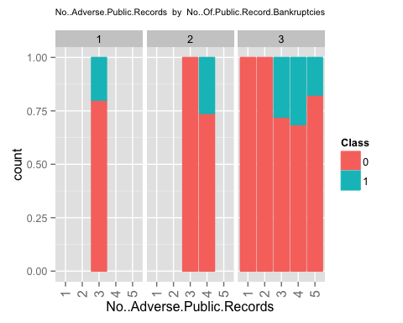 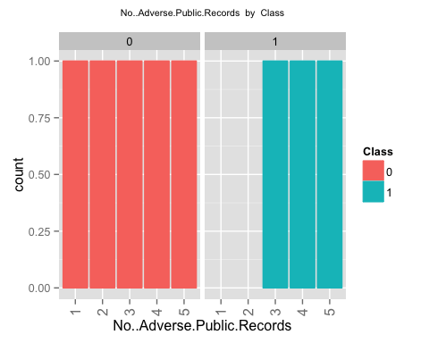 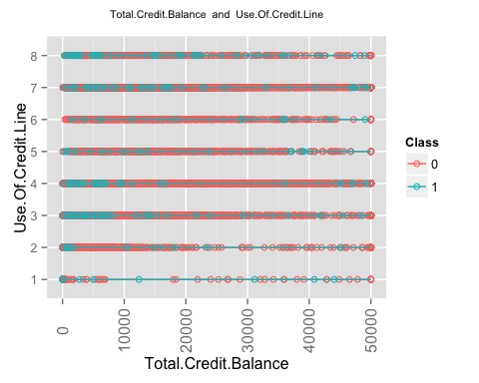 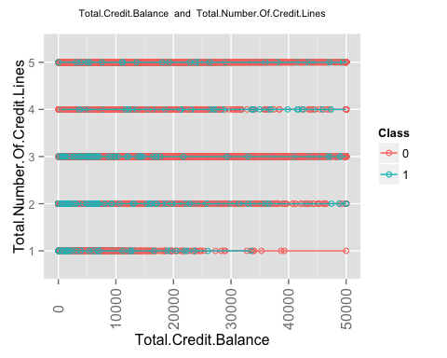 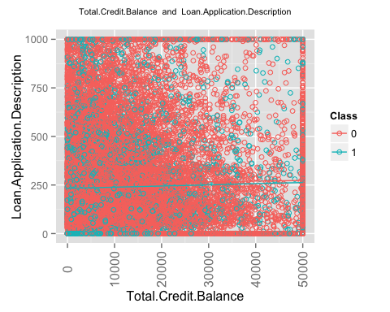 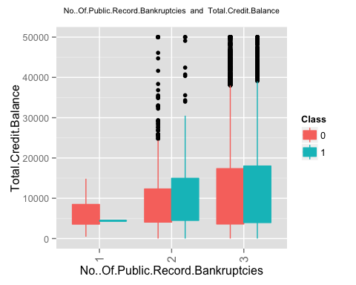 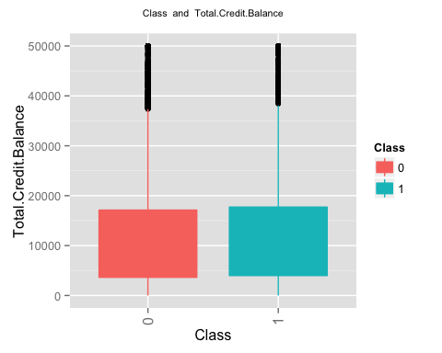

## geom_smooth: Only one unique x value each group.Maybe you want aes(group = 1)?

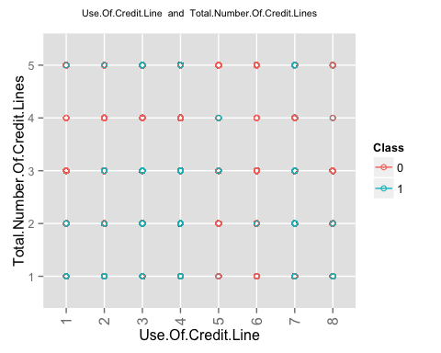

## geom_smooth: Only one unique x value each group.Maybe you want aes(group = 1)?

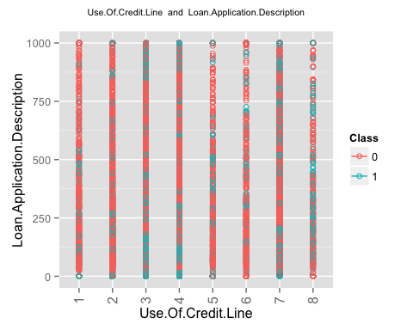 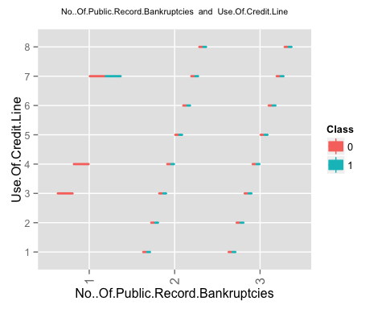 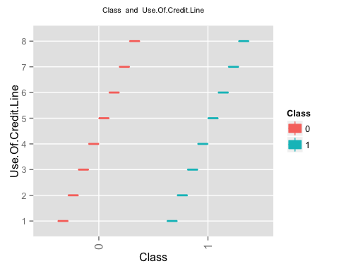

## geom_smooth: Only one unique x value each group.Maybe you want aes(group = 1)?

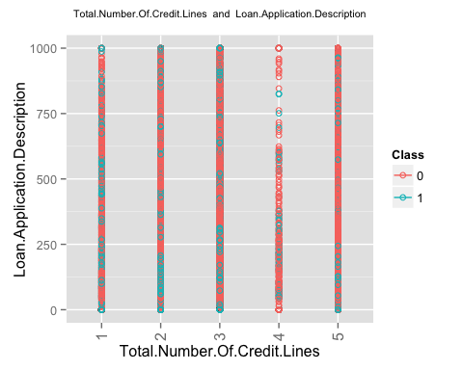 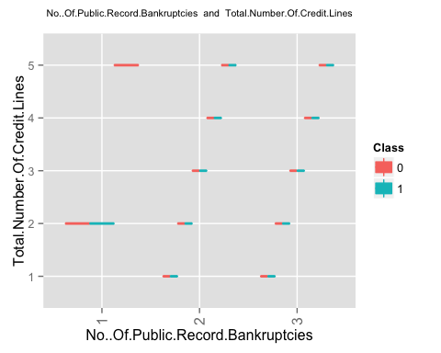 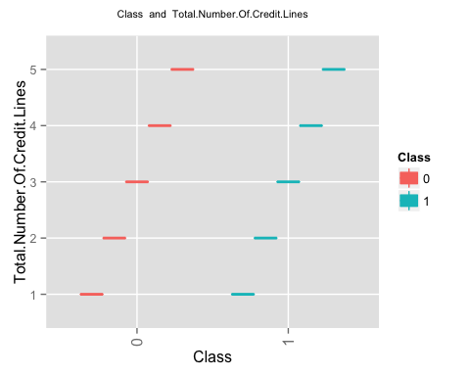 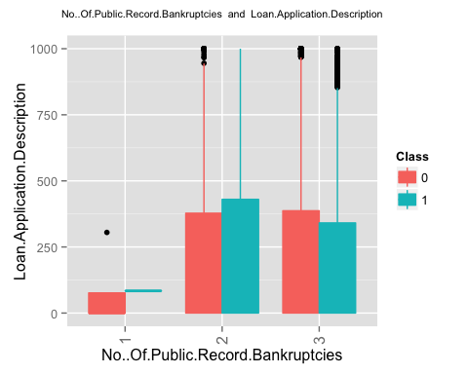 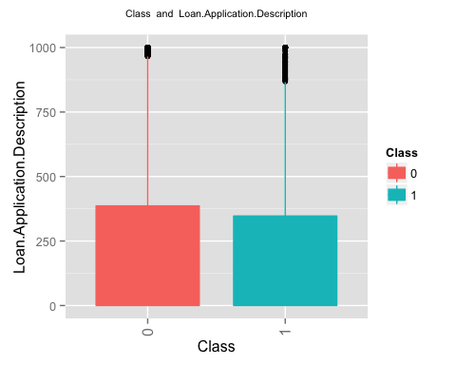

## [1] "finished generating the second set of plots i.e. plots for a pair of columns"

options(warn=0)